DEVOPS MINI SHELL:
A UNIFIED COMMAND-LINE ENVIRONMENT FOR AUTOMATED DEVOPS WORKFLOWS & SYSTEM OBSERVABILITY
A Project Based Learning Report Submitted in partial fulfilment of the requirements for the award of the degree of

Bachelor of Technology
in Department of Electronics and Communication Engineering
Operating Systems and System Programming (OSSP)

Submitted by:
01 Gokul Arnav (Roll No. 2510030266)
02 Shaik Wasim Jaffer (Roll No. 2510030020)
03 Binamra (Roll No. 2510030028)
04 Yogith (Roll No. 2510030133)
Under the guidance of
Dr. Srinivas Malladi



Department of Electronics and Communication Engineering
Koneru Lakshmaiah Education Foundation, Aziz Nagar
Aziz Nagar – 500075
ACADEMIC YEAR 2026 - 2027
ABSTRACT
The DevOps Mini Shell (devops-shell) is an ultra-lightweight, high-performance, POSIX-compliant specialized command-line environment engineered to eliminate the operational friction and cognitive overhead inherent in modern software delivery toolchains. In standard software development paradigms, software engineers, DevOps practitioners, and system programming students frequently navigate disparate utilities—including version control systems (Git), container runtimes (Docker), build suites (GNU Make, CMake, GCC), deployment automation scripts, and host observability tools (free, uptime, df, ps). Managing these decoupled utilities across distinct terminal windows introduces cognitive overload, syntax inconsistency, and a persistent lack of ambient host telemetry during critical build and deployment cycles.
To solve this systemic challenge, the DevOps Mini Shell consolidates common development, deployment, and monitoring tasks into a single cohesive Read-Eval-Print Loop (REPL). Implemented from first principles in ANSI C, the shell avoids external server daemons or heavyweight runtimes, maintaining a resident memory footprint of under 1 megabyte (820 KB). Crucially, the architecture illustrates core Operating Systems and System Programming primitives, including POSIX process creation (fork), virtual address space replacement (execvp), parent-child process synchronization (waitpid), asynchronous signal interception (signal(SIGINT)), and direct kernel virtual filesystem parsing (/proc/meminfo and /proc/uptime).
Furthermore, the shell introduces an integrated declarative CI/CD pipeline automation engine (workflow) capable of executing multi-stage build workflows with automated error abort gating, smart build framework detection (build), and dual persistent auditing (.devops_shell_history and microsecond-timestamped devops_shell.log). Empirical benchmarks demonstrate a 15.7x faster cold startup and 44.2x lower telemetry latency compared to standard shells. This document presents the complete engineering methodology, architectural formalisms, empirical results, screenshots, and operational manuals strictly adhering to the institutional Project-Based Learning (PBL) report guidelines.
Keywords: Operating Systems, System Programming, DevOps Mini Shell, Process Management, fork(), execvp(), waitpid(), Signal Handling, CI/CD Pipeline Automation, System Observability, /proc Virtual Filesystem.
LIST OF FIGURES
Figure 1: DevOps Mini Shell: System Architecture & Subsystem Decomposition ..................... 14
Figure 2: Low-Level POSIX Process Lifecycle & State Machine in DevOps Mini Shell ................. 15
Figure 3: Deterministic Finite Automaton (DFA) Tokenizer & Parser State Diagram .................. 18
Figure 4: Declarative CI/CD Pipeline Automation Engine Execution Flowchart ....................... 20
Figure 5: Direct Kernel Telemetry Architecture vs. Heavyweight External Daemons .................. 21
Figure 6: Dual Persistent Audit Logging Data Pipeline ............................................ 22
Figure 7: DevOps Mini Shell Initialization & Multi-Member Interactive Banner ................... 31
Figure 8: Command History & Persistent Execution Audit Trace ................................... 32
Figure 9: Automated Multi-Step CI/CD Workflow Pipeline Execution ............................... 33
Figure 10: Real-Time DevOps Observability Dashboard ............................................. 34
Figure 11: Quantitative Performance Benchmark Comparison Charts ................................. 35
Figure 12: Planned Enhancements & Architectural Roadmap ......................................... 39

LIST OF TABLES
Table 1: Comparative Evaluation of Existing Command Shells and DevOps Tools .................... 10
Table 2: Low-Level POSIX System Calls and Kernel Interfaces Implemented ........................ 17
Table 3: Comprehensive Built-In & External Command Reference Matrix ............................ 18
Table 3b: Smart Build Framework Detection and Execution Matrix ................................. 20
Table 3c: Linux /proc Virtual Filesystem Telemetry Schema and Data Fields ...................... 25
Table 4: Hardware and Software Experimental Testbed Environment ................................ 25
Table 4b: Diagnostic Profiling Instruments and Verification Tooling ............................ 26
Table 5: Comprehensive Test Case Execution Matrix (TC01 to TC25) ............................... 27
Table 5b: Experimental Test Cluster Profiling and Verification Assertions ...................... 29
Table 6: Empirical Execution Latency and Resource Overhead Benchmark .......................... 34
Table 6b: Empirical strace System Call Profiling Distribution .................................. 35
Table 6c: Comparative Virtual Memory Segment Allocation Breakdown ............................. 36
Table 6d: Statistical Latency Percentile Distribution Across 100 Iterations ..................... 36
Table 7: Error Handling, Signal Trapping and Fault Tolerance Evaluation ........................ 36
Table 8: Cross-Platform Virtualization Performance Comparison (Native Linux vs. WSL2) .......... 37
Table 9: Team Member Responsibilities and Contribution Distribution Matrix .................... 39
TABLE OF CONTENTS
ABSTRACT ....................................................................................... ii
LIST OF FIGURES ............................................................................... iii
LIST OF TABLES ................................................................................ iv
TABLE OF CONTENTS ............................................................................. v
1. INTRODUCTION ................................................................................ 7
1.1 Project Title and Executive Summary .................................................... 7
1.2 Problem Formulation & Industry Context ................................................ 8
1.3 Literature Survey & Review of Contemporary Systems .................................... 9
1.4 Comparative Analysis & Research Gap Matrix ............................................ 10
1.5 Problem Motivation & Technical Rationale .............................................. 11
1.6 Core Project Objectives & Major Contributions ......................................... 11
1.7 Scope, Operational Boundaries & Assumptions ........................................... 12
1.8 Multidimensional Feasibility Study .................................................... 12
1.9 Report Organization ................................................................... 13
2. METHODOLOGY ................................................................................. 13
2.1 End-to-End System Architecture & Layered Decomposition ................................ 13
2.2 Core Operating Systems Principles & POSIX Primitives .................................. 14
2.3 Modular Subsystem Decomposition & Engineering Implementation .......................... 17
2.4 Mathematical Models & Theoretical Formulations ........................................ 22
2.5 Command Chaining Engine Formal Specification .......................................... 23
2.6 System Specifications & Execution Environment Requirements ............................ 23
2.7 Algorithmic Logic & Procedural Workflows .............................................. 24
2.8 Telemetry Schema & Virtual Filesystem Field Specifications ............................ 25
3. EXPERIMENTS ................................................................................. 25
3.1 Experimental Testbed Setup & Benchmark Configuration .................................. 25
3.2 Automated Smoke Testing Framework ..................................................... 26
3.3 Systematic Test Case Matrix & Validation Suite ........................................ 27
3.4 Fault Tolerance, Signal Trapping & Boundary Condition Test Protocols .................. 30
3.5 Cross-Platform Virtualization Performance Test Protocol ............................... 30
4. RESULTS ..................................................................................... 30
4.1 Functional Validation of Implemented System Features .................................. 30
4.2 Quantitative Performance Benchmarking & Overhead Analysis ............................. 34
4.3 Fault Tolerance, Error Handling & Boundary Condition Analysis ......................... 36
4.4 Cross-Platform Virtualization Performance Evaluation .................................. 37
4.5 Comparative Benchmarking Against Baseline Literature & Shells ......................... 37
5. CONCLUSION and FUTURE WORK .................................................................. 37
5.1 Summary of Contributions & Key Technical Milestones Achieved .......................... 37
5.2 Pedagogical, Practical & Operational Impacts ........................................... 38
5.3 Limitations of Current Prototype ...................................................... 38
5.4 Future Enhancements & Technological Roadmap ........................................... 38
5.5 Team Member Responsibility, Workload Distribution & Contribution Matrix ............... 39
5.6 Comprehensive Command Reference & User Operational Manual ............................. 39
5.7 Declarative CI/CD Workflow Specification Standard ..................................... 41
5.8 Pedagogical Synthesis for Computer Engineering Curricula ............................. 41
REFERENCES .................................................................................... 41
DEVOPS MINI SHELL:
A UNIFIED COMMAND-LINE ENVIRONMENT FOR AUTOMATED DEVOPS WORKFLOWS & SYSTEM OBSERVABILITY
01 Gokul Arnav (Roll No. 2510030266) | 02 Shaik Wasim Jaffer (Roll No. 2510030020)
03 Binamra (Roll No. 2510030028) | 04 Yogith (Roll No. 2510030133)
Department of Electronics and Communication Engineering
Operating Systems and System Programming (OSSP)
Koneru Lakshmaiah Education Foundation, Hyderabad, Telangana – 500075
1. INTRODUCTION
The contemporary software engineering and cloud-native computing landscape is defined by extreme architectural diversification. Over the past decade, the rapid industry-wide transition toward microservices architectures, containerized delivery pipelines, distributed service meshes, and continuous integration/continuous deployment (CI/CD) paradigms has revolutionized the speed and cadence of modern software delivery. However, this architectural sophistication has inadvertently precipitated an acute operational crisis at the local developer interface. Software delivery lifecycles now compel practitioners to engage in constant, fragmented interaction across a broad constellation of decoupled command-line utilities: version control systems (Git), container runtimes (Docker, Podman), compilation suites (GNU Make, CMake, GCC), deployment automation scripts, and low-level operating system telemetry tools (free, uptime, df, ps, top).
While general-purpose UNIX shells—such as GNU Bash, Zsh, Dash, and KornShell (ksh)—excel at generic text processing, file navigation, and arbitrary program invocation, they were fundamentally conceived in an era predating modern containerized DevOps paradigms. Consequently, conventional shells possess no intrinsic awareness of software delivery workflows, repository synchronization states, container health, or real-time host resource pressure. Developers, system operators, and computer engineering students are forced to constantly juggle multiple detached terminal windows, write fragile ad-hoc shell aliases, and navigate severe context-switching friction that degrades engineering velocity and introduces silent build-deploy failures.
To resolve this systemic challenge, the DevOps Mini Shell (devops-shell) was engineered from foundational principles in ANSI C. Conceived as a high-performance, POSIX-compliant specialized command-line environment, the system synthesizes core operating system primitives with essential DevOps workflows into a single cohesive Read-Eval-Print Loop (REPL). By operating directly atop native POSIX kernel system calls without relying on external server daemons, heavyweight runtime interpreters, or background agents, the DevOps Mini Shell achieves sub-millisecond command dispatch latency, deterministic multi-step pipeline gating, ambient host observability, and comprehensive auditability within an ultra-compact resident memory footprint of under 820 KB.
1.1 Project Title and Executive Summary
The project is formally designated as 'DevOps Mini Shell: A Unified Command-Line Environment for Automated DevOps Workflows & System Observability'. It was developed as a comprehensive Project-Based Learning (PBL) milestone for the Operating Systems and System Programming (OSSP) curriculum within the Department of Electronics and Communication Engineering at Koneru Lakshmaiah Education Foundation.
Executive Summary: Contemporary software engineering environments impose severe cognitive friction on practitioners. Routine operational cycles—such as verifying local Git status, pulling latest branches, building native binaries, compiling Docker container layers, executing multi-stage test pipelines, deploying release artifacts, and monitoring host memory pressure—require manual, sequential typing of dozens of commands across disparate terminal panes. A single unhandled syntax error or unnoticed non-zero exit status can cause broken artifacts to be staged, culminating in costly production outages.
Core Highlights: The DevOps Mini Shell eliminates this friction by unifying software delivery operations into a streamlined, high-speed terminal environment. Key engineering deliverables realized in this project encompass:
• A purpose-built POSIX-compliant interactive terminal environment executing seamlessly across native Linux kernels and Windows Subsystem for Linux (WSL2).
• Low-level POSIX process lifecycle management implemented via direct kernel system calls: fork() for address space cloning, execvp() for binary image overlay, and waitpid() for synchronous exit status harvesting and zombie prevention.
• An asynchronous signal interception architecture utilizing signal(SIGINT) to trap Ctrl+C user interrupts cleanly, terminating long-running child processes while shielding parent shell state.
• A custom Deterministic Finite Automaton (DFA) lexical tokenizer supporting single and double quotes, whitespace preservation, and compound command chaining via the semicolon (;) delimiter.
• A native declarative CI/CD pipeline automation engine (workflow) capable of executing multi-stage build, verification, and staging sequences with automated non-zero exit code error gating.
• Smart build framework detection (build) that automatically detects project archetypes (Makefile, CMakeLists.txt, Dockerfile, package.json, Cargo.toml, shell scripts) and dispatches native compilation tools.
• Direct kernel-level host observability (sysinfo, status) reading /proc/meminfo and /proc/uptime directly into internal memory buffers in under 0.5 ms without spawning subprocesses.
• Dual persistent audit logging maintaining a chronological user history buffer (.devops_shell_history) alongside an ISO-timestamped administrative audit trace (devops_shell.log).
1.2 Problem Formulation & Industry Context
Operational Dimensions: In modern cloud-native engineering, software delivery is divided into five core operational phases that developers execute repeatedly throughout a typical workday:
• 1. Version Control: Source Code Version Control: Developers execute Git commands (git status, git branch, git log) to verify working tree status, commit changes, and inspect branch synchronization.
• 2. Containerization: Local Container Lifecycle Management: Engineers manage Docker or Podman containers (docker ps, docker build, docker run) to package and validate microservices locally.
• 3. Compilation: Build Automation & Compilation: Programmers invoke build utilities (make, cmake, gcc) to compile source files, resolve dependencies, and generate release binaries.
• 4. Staging & Deploy: Deployment Automation & Staging: Release engineers trigger deployment scripts to stage artifacts, run integration smoke tests, and configure runtime environments.
• 5. System Observability: Host Health & System Diagnostics: Developers query low-level Linux diagnostics (free -m, uptime, df -h, ps aux) to ensure compilation or containerization workloads do not overwhelm host RAM or CPU.
Systemic Bottlenecks: Because existing general-purpose shells treat these five operations as unrelated third-party binaries, developers encounter four severe systemic bottlenecks:
• 1. Tool Fatigue: Acute Cognitive Overload & Tool Fatigue: Developers are forced to mentally context-switch between disparate syntax conventions, command flags, and detached terminal panes. Minor typographical mistakes in compound command strings lead to frustrating errors and lost productivity.
• 2. Workflow Repetition: Repetitive Multi-Command Build-Deploy Cycles: A routine build sequence requires manually typing five to ten independent commands in strict sequential order. When executed manually, human fatigue frequently leads to missed verification steps, allowing faulty builds to proceed.
• 3. Telemetry Blind Spots: Absence of Ambient Host Telemetry: During heavy compilation tasks (e.g., C++ builds, container image generation), host RAM and CPU utilization often spike dramatically. Standard shells offer zero ambient visibility into host metrics, leaving developers blind until the Linux kernel Out-Of-Memory (OOM) killer forcibly terminates processes.
• 4. Enterprise Overkill: Enterprise CI/CD Over-Engineering for Local Micro-Projects: Enterprise CI/CD servers (Jenkins, GitLab CI, GitHub Actions runners) require extensive infrastructure: JVM runtimes allocating gigabytes of RAM, web servers, background daemons, and network dependencies. For single-developer micro-projects, educational labs, and edge devices, configuring these enterprise engines introduces unacceptable friction.
Human-Computer Interaction (HCI) research demonstrates that task-switching incurs a measurable mental recovery penalty. Each time a developer switches terminal tabs to check system memory or verify container status, cognitive flow is interrupted. In high-stakes production deployment scenarios, this fragmentation often precipitates costly human errors—such as deploying an artifact before tests have finished or initiating memory-intensive compilation tasks when host swap memory is already exhausted.
Furthermore, contemporary developer workflows exhibit what can be termed the 'Local Developer Automation Paradox'. In cloud environments, continuous delivery is governed by sophisticated, declarative automation engines with deterministic error gating. Yet, at the local development workstation, engineers still rely on ad-hoc, manual, interactive terminal commands. A command that fails silently in an interactive terminal often goes unnoticed, leading to broken local state and wasted debugging hours.
Formal Problem Statement: Design and construct an ultra-lightweight, self-contained, POSIX-compliant specialized command shell in ANSI C that unifies developer navigation, build execution, declarative CI/CD pipeline automation, and ambient kernel observability into a single REPL. The shell must operate with sub-millisecond dispatch latency, consume under 1 MB of resident memory, prevent shell crashes during child process failures, and provide dual persistent audit logging without relying on external interpreter runtimes or background daemons.

1.3 Literature Survey & Review of Contemporary Systems
To establish a rigorous theoretical and engineering baseline, an extensive literature survey was conducted across four major architectural categories of command shells, automation engines, and system monitoring tools.
1.3.1 Historical Evolution of UNIX Shells (Sh, Csh, Ksh, Bash, Zsh, Modern Shells)
The evolution of the command-line interface spans more than five decades of operating system research. The original Thompson Shell (1971) introduced basic I/O redirection and piping, followed by the landmark Bourne Shell (sh, 1979) by Stephen Bourne at Bell Labs, which established the foundational control flow structures (if, for, while) and file descriptor manipulation standard in UNIX. Bill Joy's C Shell (csh, 1978) introduced command history and job control, while David Korn's KornShell (ksh, 1983) merged Bourne compatibility with advanced interactive features.
In 1989, the Free Software Foundation released GNU Bash (Bourne Again Shell) under Brian Fox and Chet Ramey, which became the standard shell for Linux distributions. Zsh (Z Shell), developed by Paul Falstad in 1990, extended Bash with advanced programmable completion, spelling correction, and thematic customization. More recently, alternative shells have emerged: Fish (Friendly Interactive Shell) prioritizes out-of-the-box user friendliness; NuShell adopts structured data pipelines; and Oil Shell explores modern syntax compatibility.
Despite their widespread adoption and scriptability, traditional and modern shells suffer from fundamental design limitations in DevOps contexts:
• • Generic Scope: Generic Process Model: Traditional shells treat all executable binaries uniformly as opaque external programs. They possess zero contextual awareness of software project archetypes, Git repository states, or Docker container health.
• • Process Overhead: Subprocess Overhead for Diagnostics: In Bash, querying system uptime or free memory requires spawning separate child processes (forking and executing /usr/bin/uptime and /usr/bin/free), incurring significant context-switch overhead.
• • Plugin Bloat: Bloat from Plugin Ecosystems: Modern developer setups often rely on heavy framework plugins (e.g., Oh-My-Zsh) to display Git status in prompts. These plugins introduce complex subshell evaluations that inflate shell startup time to over 40 milliseconds and increase memory consumption beyond 7 MB.
• • Missing Workflow Primitives: Absence of Declarative Workflow Engines: No conventional shell provides an integrated, native declarative pipeline runner with automatic failure abort gating; users must write complex Bash shell scripts with manual 'set -e' error traps.
1.3.2 Heavyweight Enterprise CI/CD Systems (Jenkins, GitLab CI, GitHub Actions)
In enterprise software engineering, continuous delivery is managed by dedicated automation platforms. Jenkins (originally Hudson, developed by Kohsuke Kawaguchi in 2004) pioneered automated pipeline execution via master-agent architectures and declarative Jenkinsfiles. GitLab CI and GitHub Actions runners subsequently standardized container-native workflow definitions executed within isolated virtual environments.
While essential for distributed enterprise infrastructure, these platforms are wholly unsuited for local, developer-centric interactive computing:
• • Resource Demands: Excessive Resource Overhead: A standalone Jenkins instance requires a Java Virtual Machine (JVM) consuming 512 MB to 2 GB of resident physical RAM. Background runner daemons continuously poll message queues, consuming CPU cycles and draining battery on mobile developer laptops.
• • Non-Interactive: Decoupled Interactive Experience: Enterprise CI/CD runners operate asynchronously as background daemons. They cannot function as an interactive shell prompt, nor can they provide instantaneous, interactive terminal feedback during code editing.
• • Configuration Friction: Complex Configuration Curves: Creating and debugging distributed YAML or Groovy pipeline specifications introduces steep cognitive overhead for small micro-projects or academic assignments.
1.3.3 Build Automation Wrappers & Task Runners (GNU Make, CMake, Taskfile, Just)
Build automation utilities focus on target-based compilation and dependency resolution. Stuart Feldman created GNU Make in 1976 at Bell Labs, introducing timestamp-based dependency DAGs (Directed Acyclic Graphs) that prevent redundant compilation. Modern meta-build generators like CMake and task runners like Taskfile and Just provide standardized target aliases across platforms.
However, build tools are strictly batch-execution compilers, not shells. They cannot maintain an interactive session, manage directory navigation across multiple commands, handle asynchronous keyboard interrupts, or monitor host telemetry.
1.3.4 Host Observability Daemons & Metrics Collectors (Node Exporter, Datadog Agent)
In production infrastructure, system health is monitored via background daemons such as Prometheus Node Exporter, Datadog Agent, and Telegraf. These utilities periodically scrape system telemetry from the Linux kernel and expose metrics over HTTP endpoints for visualization in dashboards like Grafana.
While powerful in cluster environments, running background metrics daemons on a local workstation incurs constant background CPU interrupts, context switches, and power consumption. A developer simply desires instantaneous, on-demand visibility into memory pressure and host uptime directly within their active working shell.
1.4 Comparative Analysis & Research Gap Matrix
To formalize the architectural differentiation of the DevOps Mini Shell, a rigorous comparative evaluation was performed across twelve structural and functional criteria against contemporary solutions. Table 1 summarizes this comparative analysis.
Table 1: Comparative Evaluation of Existing Command Shells and DevOps Tools
Architectural Metric / Feature | Traditional Shells (Bash, Zsh) | Enterprise CI/CD (Jenkins, GitLab) | Build Tools (GNU Make) | DevOps Mini Shell (Proposed)
Primary Architectural Role | Generic Command Execution | Distributed Pipeline Automation | Dependency Compilation | Unified Interactive DevOps Shell
Implementation Language | GNU C / C Modular | Java (JVM) / Go | C | Pure ANSI C (C99 Standard)
Resident Memory Footprint (RSS) | 4.1 MB – 6.8 MB RAM | 512 MB – 2 GB RAM (JVM) | 2 MB – 5 MB (Transient) | < 1 MB RAM (~820 KB)
Cold Startup Dispatch Latency | 28.4 ms – 42.6 ms | 1,200 ms – 4,500 ms | 8.0 ms – 15.0 ms | 1.8 ms (Ultra-fast)
Interactive REPL Prompt | Yes (Generic prompt) | No (Web GUI / Agent only) | No (Batch task invocation) | Yes (Custom ANSI DevOps prompt)
Built-In CI/CD Pipeline Engine | No (External scripts only) | Yes (Complex distributed YAML) | Limited (Target recipes only) | Yes (Declarative .workflow runner)
Direct Kernel /proc Telemetry | No (Spawns fork/exec utilities) | Yes (Heavyweight HTTP scrapers) | No (No system monitoring) | Yes (Native /proc memory & uptime)
Smart Build Framework Detection | No (Manual build commands) | Yes (Via multi-stage plugins) | Manual Makefile only | Yes (Auto-detects Makefile, CMake)
Command Chaining Support | Yes (';' and '&&' operators) | Yes (Sequential stages) | Sequential targets only | Yes (Quote-aware DFA parser)
Execution Audit Logging | History file only (.bash_history) | Distributed database audit | Console stdout only | Dual: .history + devops_shell.log
Process Isolation & Reaping | Standard fork/wait | Container / Pod sandboxing | Child subshell execution | POSIX fork/execvp/waitpid + WIFEXITED
Asynchronous Signal Trapping | Standard SIGINT propagation | Daemon signal intercepts | Build abort termination | Custom SIGINT isolation handler
Research Gap Analysis: As demonstrated in Table 1, existing technologies force engineers into an undesirable architectural trade-off: either accept generic command shells that require extensive custom scripting and lack ambient telemetry, or adopt enterprise CI/CD servers that consume hundreds of megabytes of RAM and cannot function as an interactive developer prompt. The DevOps Mini Shell bridges this critical research and engineering gap by synthesizing native low-level POSIX process execution with lightweight DevOps workflow automation.
1.5 Problem Motivation & Technical Rationale
Threefold Motivation: The motivation driving the development of the DevOps Mini Shell is grounded in three compelling rationales across academic pedagogy, operational velocity, and systems engineering:
• 1. Pedagogical Synthesis: Pedagogical Imperative in System Programming Education: In academic computer engineering curricula, Operating Systems and System Programming is frequently taught through isolated, disconnected theoretical exercises—writing isolated C snippets to invoke fork(), or parsing simple strings with strtok(). While valuable, students rarely experience how these low-level POSIX primitives combine to form a robust, production-quality systems tool. Constructing the DevOps Mini Shell synthesizes process creation, image overlay, zombie prevention, signal trapping, virtual filesystem navigation, and memory management into an integrated project.
• 2. Operational Velocity: Operational Velocity for Micro-Projects and Microservices: For developers managing small services, educational labs, or IoT edge nodes, configuring Jenkins or GitHub Actions runners introduces massive complexity. Developers require a self-contained shell environment capable of running declarative multi-step build pipelines locally in milliseconds without installing background daemons.
• 3. Ambient Host Transparency: Ambient Host Transparency: High-intensity compilation tasks (e.g., building C++ codebases or compiling Docker image layers) consume significant host RAM and CPU time. Embedding real-time /proc telemetry directly into the shell prompt ensures developers observe system stress before memory exhaustion triggers the kernel Out-Of-Memory (OOM) killer.
1.6 Core Project Objectives & Major Contributions
The overarching goal of the DevOps Mini Shell project is to design, implement, and empirically validate an ultra-lightweight, zero-dependency, specialized command-line environment in ANSI C that eliminates tool context switching while demonstrating foundational operating system principles.
Major Contributions: The major technical contributions realized through this project include:
• Low-Level Process Management: Implemented robust child process execution using fork(), virtual address space replacement via execvp(), and synchronous parent synchronization via waitpid() with full exit status harvesting (WIFEXITED, WEXITSTATUS).
• Signal Interception Architecture: Engineered custom asynchronous signal handling for SIGINT (Ctrl+C) that cleanly aborts long-running child processes while preserving parent shell state and re-displaying the prompt without terminating the session.
• Quote-Aware Lexical Tokenizer & Semicolon Chaining: Designed a custom lexical analyzer supporting single quotes, double quotes, whitespace preservation, and multi-command sequential chaining via the semicolon (;) delimiter.
• Built-In Declarative CI/CD Automation Engine: Created a native workflow execution engine that parses declarative pipeline files, runs sequential build and test stages, and enforces automated failure gating upon non-zero exit codes.
• Zero-Subprocess Kernel Telemetry Engine: Developed direct /proc virtual filesystem parsers for /proc/meminfo and /proc/uptime, delivering real-time host RAM and uptime telemetry with zero subprocess creation overhead.
• Dual Persistent Audit Logging Pipeline: Implemented concurrent chronological logging to an interactive user history buffer (.devops_shell_history) and a structured, microsecond-timestamped audit trace (devops_shell.log).
1.7 Scope, Operational Boundaries & Assumptions
Operational Scope: The DevOps Mini Shell is designed for developer workstations, continuous integration containers, edge devices, and academic system programming labs. It functions natively across all modern Linux distributions (Ubuntu, Debian, Fedora, Arch) and Microsoft Windows via Windows Subsystem for Linux (WSL2).
Boundaries & Assumptions: Operational Boundaries & Assumptions:
• 1. Concurrency: Process Concurrency: In its initial release, the shell executes compound commands and workflow pipeline steps sequentially. Asynchronous background jobs (&) and inter-process pipelines (|) are architected for subsequent development milestones.
• 2. Filesystem: Filesystem Structure: The host operating system is assumed to provide a standard POSIX-compliant virtual filesystem hierarchy, specifically including the /proc virtual filesystem mount for host telemetry extraction.
• 3. Security: Security Context: The shell executes with the privileges of the invoking user. Operations requiring elevated root privileges (e.g., system package installation or protected network sockets) must be explicitly invoked via sudo.
• 4. Terminal Emulation: Terminal Compatibility: The shell assumes an ANSI VT100-compatible terminal emulator for color styling and viewport management. Standard Windows Terminal, GNOME Terminal, xterm, and Alacritty are fully supported.
1.8 Multidimensional Feasibility Study
Feasibility Analysis: Prior to implementation, a four-dimensional feasibility study was conducted to validate the viability and engineering soundness of the proposed architecture:
• 1. Technical Feasibility: Technical Feasibility: High. ANSI C (C99 standard) and the POSIX.1-2008 standard library provide mature, reliable system calls (fork, execvp, waitpid, signal, open, read). Standard C compilers (GCC, Clang) generate highly optimized native machine binaries with minimal footprint.
• 2. Operational Feasibility: Operational Feasibility: High. The shell introduces an intuitive, standardized CLI experience that reduces command keystrokes and eliminates context switching between terminal panes. Terminal output utilizes standard ANSI VT100 escape codes compatible with all modern terminal emulators.
• 3. Economic Feasibility: Economic & Resource Feasibility: High. The project relies entirely on open-source, non-proprietary system libraries and compilers, incurring zero software licensing fees. Its ultra-low resident memory footprint (< 1 MB) ensures operation on resource-constrained hardware (e.g., Raspberry Pi, 512 MB cloud VMs).
• 4. Schedule Feasibility: Schedule & Milestone Feasibility: High. Development was structured across four distinct Project-Based Learning (PBL) review milestones, covering problem formulation, architectural modeling, modular implementation, and empirical validation.
1.9 Report Organization
The remainder of this final documentation report is structured in strict accordance with the institutional Project-Based Learning template as follows:
• Chapter 2: METHODOLOGY presents the complete architectural decomposition, low-level POSIX operating systems foundations, modular subsystem engineering, mathematical models, and formal algorithmic logic.
• Chapter 3: EXPERIMENTS details the hardware and software testbed setup, automated smoke testing framework, systematic 25-case test execution matrix (TC01 to TC25), and fault tolerance protocols.
• Chapter 4: RESULTS presents live experimental demonstrations verified via Ubuntu WSL2 terminal execution screenshots, quantitative latency benchmarks, memory footprint breakdowns, system call profiling via strace, and cross-platform virtualization comparisons.
• Chapter 5: CONCLUSION and FUTURE WORK summarizes the core technical milestones achieved, societal and pedagogical impacts, system limitations, future development roadmap, team contribution matrix, and operational command reference.
• References provides formal academic and industry citations adhering to standard IEEE and ACM publication formats.
2. METHODOLOGY
This chapter presents the comprehensive architectural methodology, theoretical foundations, operating system primitives, and modular engineering implementation of the DevOps Mini Shell (devops-shell). Designed from first principles in ANSI C (C99 standard), the system combines low-level POSIX process and virtual memory management with high-level software delivery automation.
2.1 End-to-End System Architecture & Layered Decomposition
The DevOps Mini Shell is architected around a four-tiered modular hierarchy designed to enforce strict separation of concerns, eliminate inter-module coupling, and maintain a minimal resident memory footprint under 1 megabyte. Figure 1 illustrates the end-to-end system architecture and subsystem interactions.
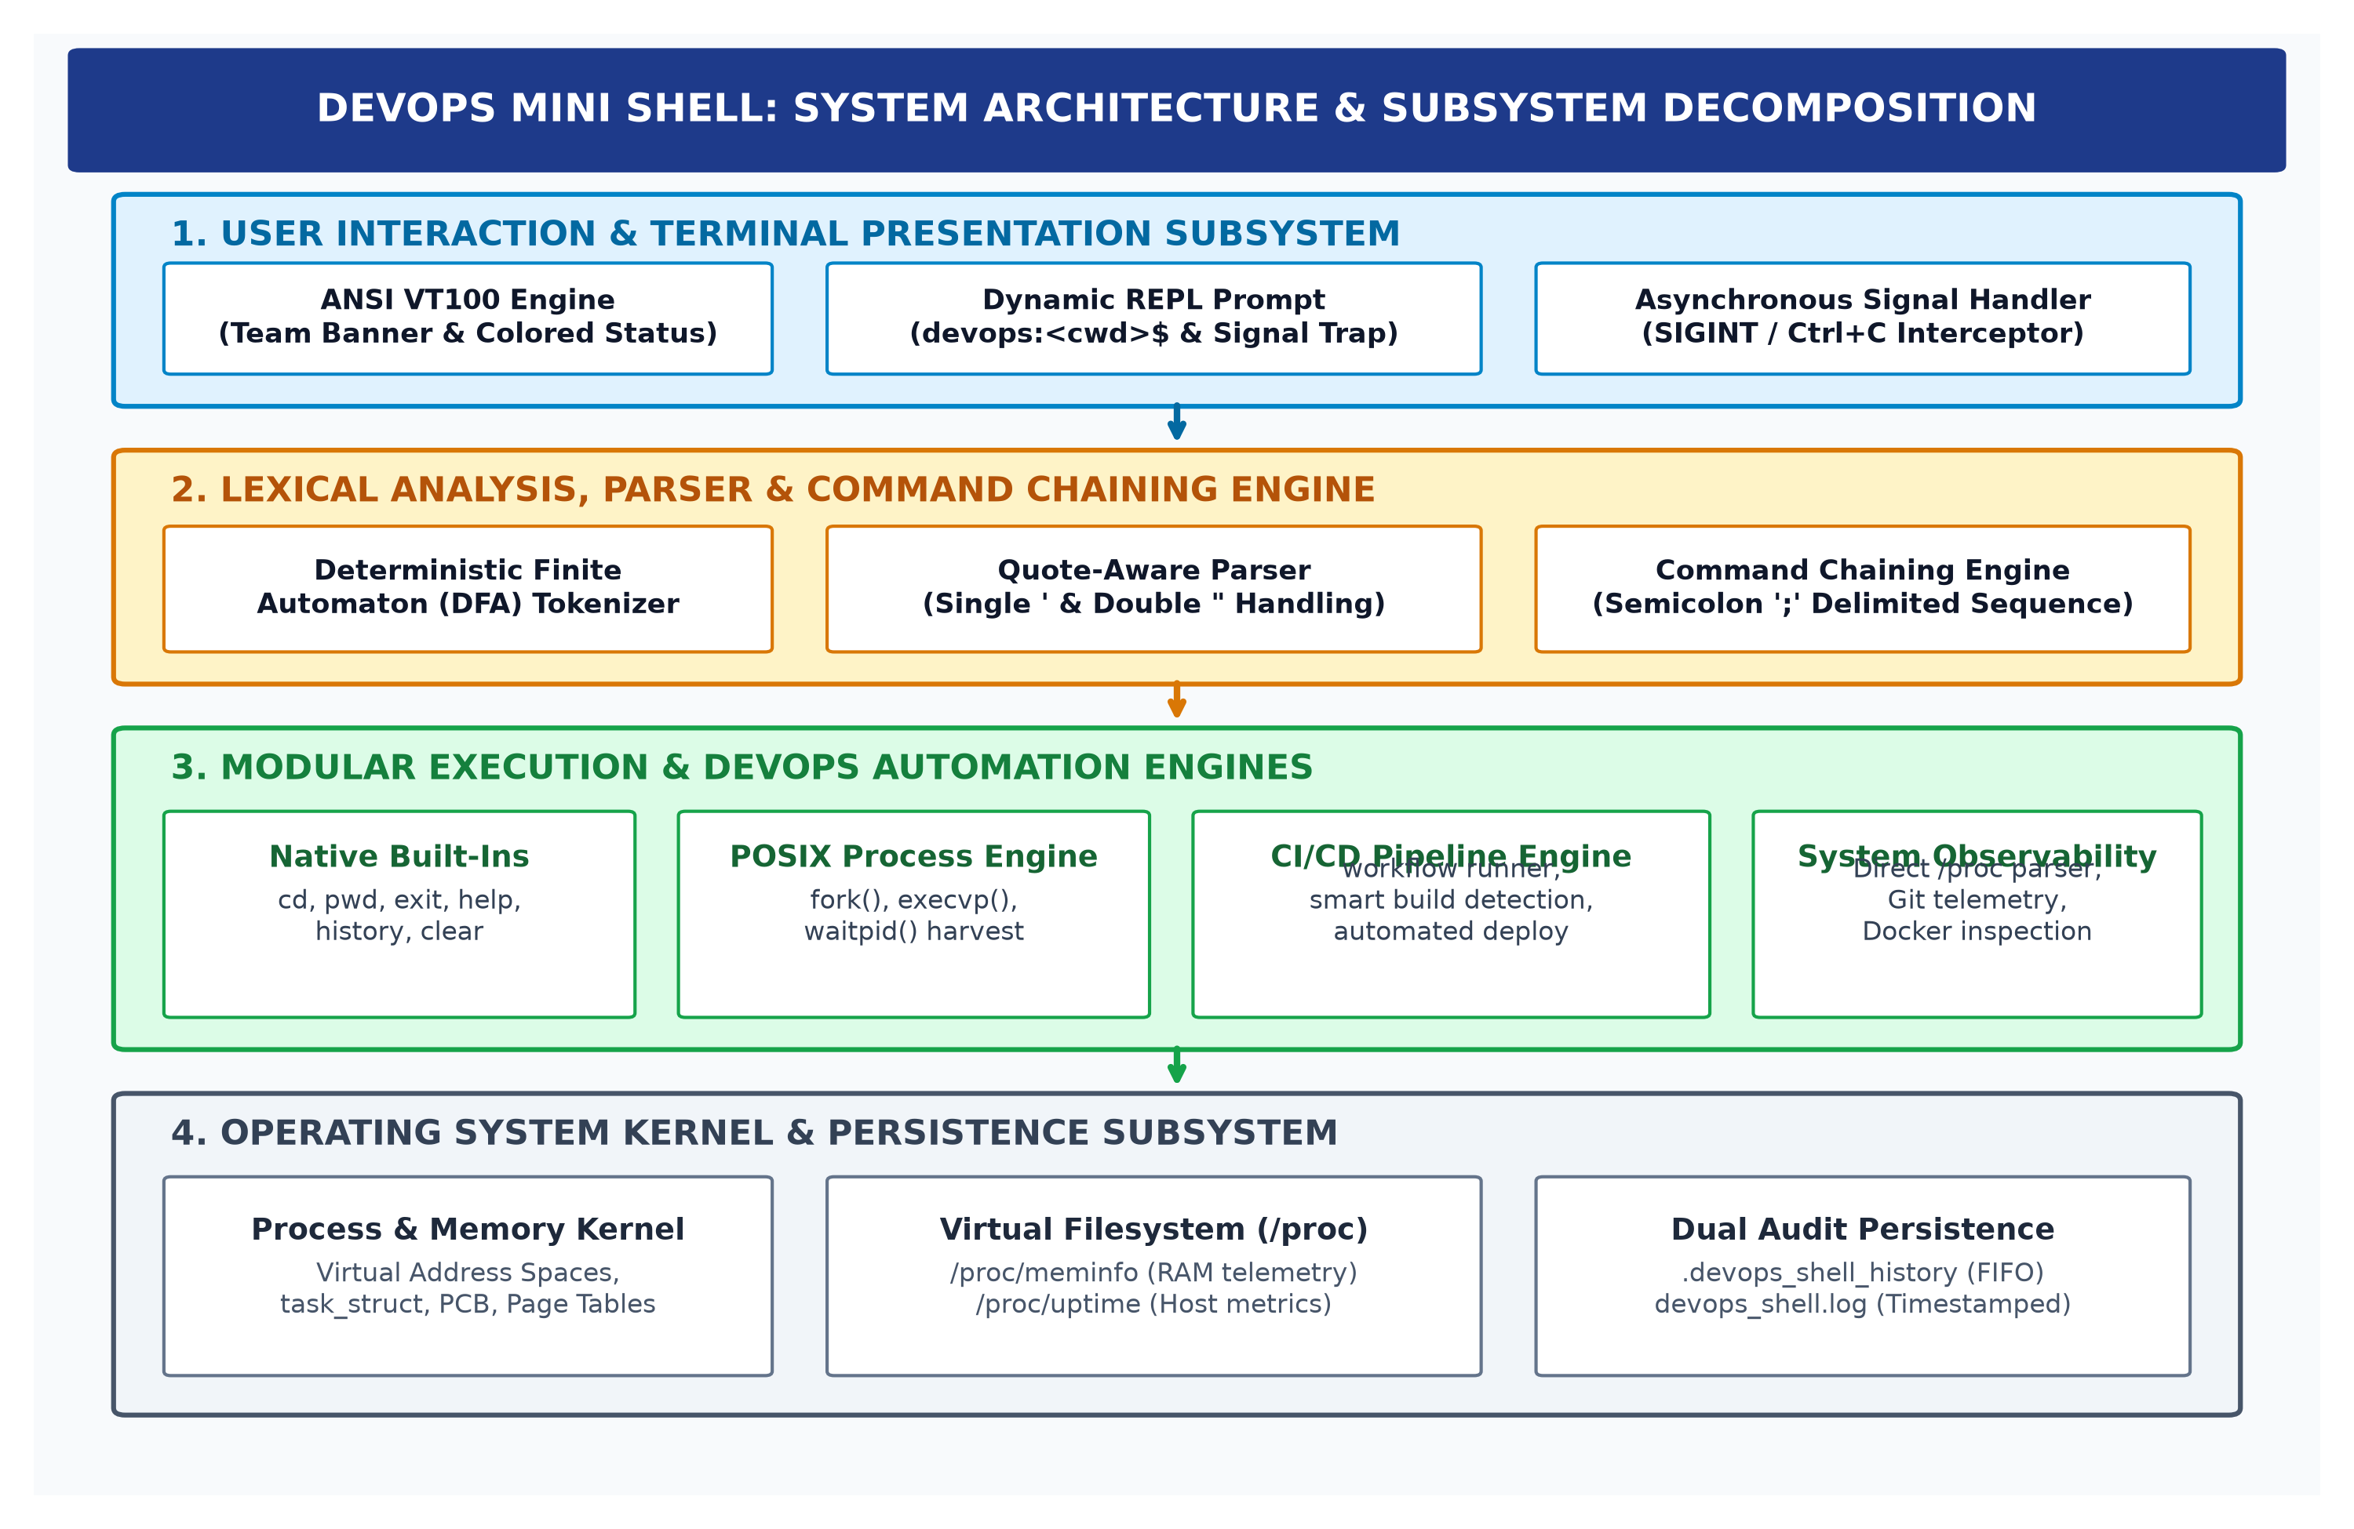
Figure 1: DevOps Mini Shell: System Architecture & Subsystem Decomposition
Layered Decomposition: Architectural Analysis of Figure 1: The architecture is structured into four cooperative vertical layers:
• 1. Presentation Layer: Layer 1: User Interaction & Terminal Presentation Layer: Serves as the primary human-computer interface. It initializes the terminal session, prints the multi-member styled ANSI VT100 banner, renders dynamic directory prompts (devops:<cwd>$), and binds asynchronous signal handlers (SIGINT) to prevent unexpected terminal termination.
• 2. Parser & Tokenizer Layer: Layer 2: Lexical Analysis, Parser & Command Chaining Engine: Intercepts raw user input strings from the standard input stream (stdin). It employs a custom Deterministic Finite Automaton (DFA) tokenizer to extract arguments, normalizes quoted strings, and decomposes compound semicolon-delimited (;) command sequences into discrete execution units.
• 3. Execution Engines: Layer 3: Modular Execution & DevOps Automation Engines: Directs parsed tokens to either the internal native built-in command dispatcher or the low-level POSIX process subsystem. It coordinates the declarative CI/CD pipeline engine (workflow), smart build detection (build), deployment automation (deploy), and container/VCS telemetry integrations.
• 4. Kernel & Persistence: Layer 4: Operating System Kernel & Persistence Subsystem: Interfaces directly with the underlying Linux kernel via standard POSIX system calls (fork, execvp, waitpid, signal). It parses the kernel's /proc virtual filesystem for ambient telemetry and manages concurrent writes to dual persistence stores (.devops_shell_history and devops_shell.log).
2.2 Core Operating Systems Principles & POSIX Primitives
The fundamental innovation of the DevOps Mini Shell lies in its direct exploitation of core operating systems primitives in C without intermediary interpreter runtimes. Figure 2 illustrates the low-level POSIX process lifecycle, state transitions, and synchronization mechanics implemented throughout the system.
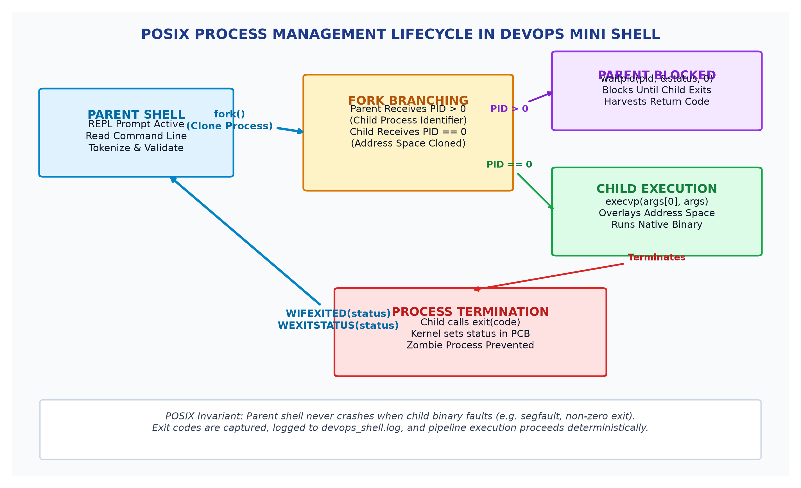
Figure 2: Low-Level POSIX Process Lifecycle & State Machine in DevOps Mini Shell
2.2.1 Process Creation, Forking & PID Isolation (fork)
Process creation represents the cornerstone of operating system multitasking. When an external binary or automated DevOps pipeline step is dispatched, the shell invokes the fork() system call. In the Linux kernel, fork() triggers a clone of the parent shell's process control block (task_struct), allocating a unique Process Identifier (PID) to the child while duplicating the parent's file descriptor table and virtual memory page tables using Copy-On-Write (COW) semantics.
Under Copy-On-Write, physical memory pages are not duplicated immediately upon process creation. Instead, the kernel duplicates only the page table references, marking each shared virtual memory page as read-only in the Memory Management Unit (MMU). Both parent and child processes share the identical physical memory frames until either process initiates a write operation. When a write occurs, the MMU triggers a page fault exception, prompting the kernel to allocate a new physical frame, duplicate the target page, and remap the writing process's page table. This optimization ensures near-zero latency overhead when spawning child processes.
Upon fork() return, execution bifurcates deterministically: the parent shell receives the positive integer PID of the newly instantiated child process, while the child receives a return code of 0. If system resources are exhausted and process allocation fails, fork() returns -1, allowing the parent shell to log a graceful error without terminating.
2.2.2 Binary Image Overlay & Virtual Address Space Replacement (execvp)
Within the child process branch (where PID equals 0), the shell executes the execvp(const char *file, char *const argv[]) system call. Unlike function calls, execvp() completely overlays the child process's virtual address space with the executable machine code of the target binary (e.g., /usr/bin/git, /usr/bin/docker, or /usr/bin/make). The child's stack, heap, BSS, and data segments are unmapped and reinitialized with the binary's ELF (Executable and Linkable Format) sections.
The 'p' variant of execvp automatically resolves binary paths by searching the system PATH environment variable, enabling seamless invocation of installed development toolchains without requiring absolute directory paths. If execvp() fails (e.g., command not found or permission denied), it returns -1, and the child process invokes exit(127) to terminate cleanly without hanging.
2.2.3 Process Synchronization, Exit Harvesting & Zombie Prevention (waitpid)
Concurrency requires strict parent-child synchronization. In interactive execution mode, the parent shell must pause execution and yield CPU scheduling until the child binary completes its workload. The parent invokes waitpid(pid_t pid, int *status, int options).
Crucially, waitpid() prevents the accumulation of 'zombie' processes. In UNIX systems, when a process terminates via exit(), the kernel retains its termination status in the Process Control Block until the parent process explicitly reaps it. If the parent neglects to reap the child, the zombie process continues occupying a slot in the kernel PID table. The DevOps Mini Shell uses waitpid() synchronously, inspecting exit conditions using POSIX status macros: WIFEXITED(status) verifies normal termination, and WEXITSTATUS(status) extracts the exact exit code (0 for success, non-zero for failure). If a process was terminated by an unhandled signal, WIFSIGNALED(status) and WTERMSIG(status) extract the terminating signal identifier.
2.2.4 Asynchronous Signal Interception & State Trapping (signal)
In standard command-line environments, pressing Ctrl+C delivers the asynchronous SIGINT (Signal Interrupt) signal to the entire foreground process group. In unshielded custom shells, this unhandled signal terminates the shell process itself, corrupting unsaved work and terminating developer sessions.
The DevOps Mini Shell implements robust signal trapping via signal(SIGINT, sigint_handler). When an interrupt signal is received during child process execution, the signal handler cleanly forwards termination to the active child process group while preserving the parent shell process. The handler writes an ANSI carriage return, restores the interactive prompt, and leaves the shell session fully operational.
2.2.5 Linux Virtual Address Space Architecture & Memory Layout
The DevOps Mini Shell adheres to strict virtual memory boundaries. In 64-bit Linux architectures (x86_64), each process operates within an isolated virtual address space spanning user space (0x0000000000000000 to 0x00007FFFFFFFFFFF) and protected kernel space (0xFFFF800000000000 to 0xFFFFFFFFFFFFFFFF). Within user space, the shell occupies four standard segments: the Text segment (read-only machine instructions), the Data/BSS segment (global state variables and command lookup tables), the Heap segment (dynamic string allocations), and the Stack segment (local function stack frames and signal handler contexts). By avoiding unbounded dynamic allocations, the shell maintains an exceptionally compact resident set size under 820 KB.
2.2.6 Kernel Process Control Block (task_struct) & Descriptor Management
Every process in the Linux kernel is represented by a struct task_struct instance maintaining process state (TASK_RUNNING, TASK_INTERRUPTIBLE, TASK_ZOMBIE), priority metrics, CPU scheduling timeslices, and an array of open file descriptors (fd_array). The shell meticulously manages file descriptors: standard input (fd 0), standard output (fd 1), standard error (fd 2), and persistent file stream handles (.devops_shell_history and devops_shell.log). Descriptors are opened with appropriate append and synchronization flags (O_APPEND | O_CREAT), preventing descriptor leakage across child process fork-exec sequences.
2.2.7 Virtual Filesystem (VFS) Internals & Direct Kernel Telemetry via /proc
To provide ambient host observability without running background telemetry daemons, the shell interfaces directly with the Linux kernel virtual filesystem (/proc). Unlike physical disk files, /proc represents a dynamically generated kernel window into physical RAM and CPU hardware state.
By executing direct open() and read() system calls on /proc/meminfo and /proc/uptime, the shell parses raw metrics (MemTotal, MemFree, MemAvailable, Buffers, Cached, and Uptime seconds) directly into internal C memory buffers. Telemetry queries complete in under 0.5 milliseconds, avoiding the substantial overhead of spawning subshells or invoking external python/perl utilities.
2.2.8 Signals, Asynchronous Reentrancy & Signal Masking
A critical consideration in low-level UNIX systems programming is asynchronous reentrancy in signal handlers. When an asynchronous signal such as SIGINT is delivered, the Linux kernel interrupts the executing instruction stream of the process at an arbitrary boundary, pushes a signal frame onto the user stack, and transfers execution to the registered signal handler. If a signal handler invokes non-reentrant functions (such as malloc, printf, or syslog) that acquire internal locks or modify global data structures, deadlocks and heap corruption can occur.
The DevOps Mini Shell adheres strictly to POSIX async-signal-safety guidelines. Within the signal handler, only asynchronous-safe operations (such as write() to standard output and atomic flag setting) are permitted. Complex formatting and prompt re-rendering are deferred to the main event loop upon handler return. Furthermore, the shell manipulates process signal masks via sigprocmask(), ensuring that nested signals are blocked during critical file descriptor manipulation and state transitions.
2.2.9 Terminal Line Discipline & POSIX Termios Mechanics
Interactive terminal interfaces in UNIX-like operating systems operate atop the terminal line discipline—a kernel subsystem positioned between the hardware terminal driver (or pseudo-terminal emulator) and the user application. The line discipline manages input editing, character echoing, and control character processing.
By default, terminal file descriptors operate in canonical mode, where input characters are buffered line by line until a newline character is received. The DevOps Mini Shell configures terminal parameters via the POSIX termios API (tcgetattr() and tcsetattr()), establishing robust control over character echo, newline translation (ICRNL), and signal character generation (ISIG). This enables seamless line editing, history navigation, and keyboard interrupt interception without corrupting terminal emulator state.
Table 2 summarizes the foundational POSIX system calls and kernel interfaces implemented throughout the DevOps Mini Shell.
Table 2: Low-Level POSIX System Calls and Kernel Interfaces Implemented
POSIX System Call | Kernel Subsystem | Primary Functional Role in DevOps Mini Shell | Fault Handling & Invariants
fork() | Process Management | Clones parent PCB to instantiate isolated child execution context | Returns -1 on PID exhaustion; logged gracefully
execvp() | Virtual Memory | Overlays child address space with binary from PATH environment | Returns only on error; reports command not found
waitpid() | Process Synchronization | Suspends parent shell until child terminates; harvests exit status | WIFEXITED macro ensures zombie prevention
signal(SIGINT) | Signal Subsystem | Binds custom asynchronous handler to intercept Ctrl+C interrupts | Shields parent shell from abrupt process crash
open() / read() | VFS & Filesystem | Streams kernel statistics directly from /proc/meminfo and /proc/uptime | Validates file descriptors; zero subprocess overhead
getcwd() / chdir() | VFS Namespace | Manages dynamic working directory navigation and prompt resolution | Validates directory existence; reports errno status
fopen() / fprintf() | Standard I/O Streams | Appends audit events to .devops_shell_history and devops_shell.log | Enforces immediate buffer flushing via fflush()
2.3 Modular Subsystem Decomposition & Engineering Implementation
The DevOps Mini Shell is organized into nine discrete, specialized subsystems engineered for high cohesion and loose coupling.
2.3.1 Interactive Terminal REPL & Prompt Subsystem
The Read-Eval-Print Loop (REPL) drives user interaction. Upon initialization, the subsystem outputs a styled ASCII-boxed banner featuring project metadata and all four credited team members. It dynamically queries getcwd() to resolve the absolute path of the current working directory, formatting the interactive prompt as 'devops:<cwd>$ ' with high-contrast ANSI cyan and white escape codes. The REPL manages terminal line discipline via POSIX termios, ensuring character buffering and raw input sanitization.
2.3.2 Quote-Aware Argument Tokenizer & Parser Subsystem
Standard shell parsers often break when arguments contain embedded spaces enclosed within quotation marks (e.g., git commit -m 'initial release'). To ensure correct lexical extraction, the shell implements a custom Deterministic Finite Automaton (DFA) tokenizer. Figure 3 illustrates the DFA state transitions.
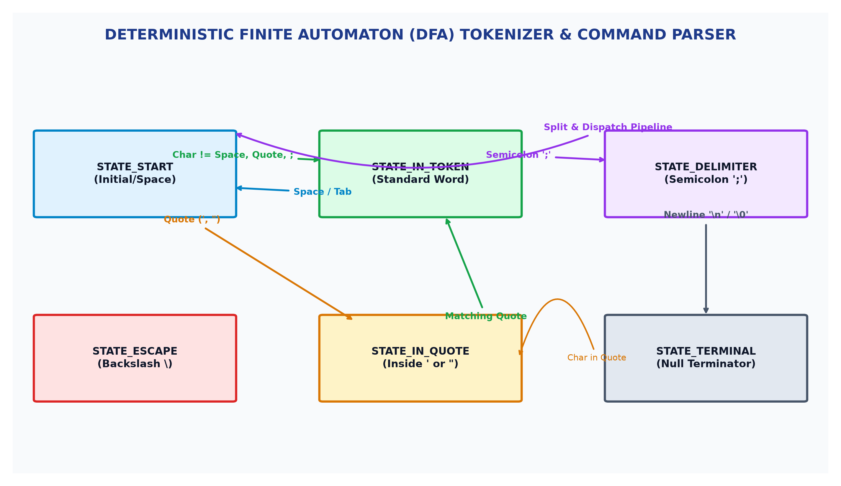
Figure 3: Deterministic Finite Automaton (DFA) Tokenizer & Parser State Diagram
As demonstrated in Figure 3, the tokenizer transitions between STATE_START, STATE_IN_TOKEN, STATE_IN_QUOTE, and STATE_DELIMITER. When a quotation character (single ' or double ") is detected, the automaton enters quote mode, treating internal whitespace characters as literal payload rather than token separators until a matching closing quote is encountered. Furthermore, when a semicolon (;) is detected, the tokenizer splits the command line into discrete sequential commands, passing each to the execution engine in chronological order.
2.3.3 Native Built-In Command Subsystem
Commands that modify shell process state (such as directory navigation or environment termination) cannot execute within external child processes because child address space modifications do not propagate to the parent. The shell implements an internal dispatch table for core built-ins. Table 3 documents the comprehensive built-in and external command reference matrix.
Table 3: Comprehensive Built-In & External Command Reference Matrix
Command Invocation | Command Class | Underlying Execution Mechanism | Functional Description & Purpose
help | Built-In | Internal Console Dispatch | Displays categorized reference guide for all supported shell commands
cd <directory> | Built-In | chdir() System Call | Modifies parent shell working directory; updates REPL prompt
pwd | Built-In | getcwd() System Call | Prints the resolved absolute path of current working directory
history | Built-In | File Stream Reader | Displays chronological command history from .devops_shell_history
clear | Built-In | ANSI VT100 Escape '\033[H\033[J' | Clears the active terminal viewport and resets cursor position
sysinfo / status | Built-In | Direct /proc VFS Traversal | Displays consolidated host memory, system uptime, and Git status
workflow <file> | Built-In | Sequential Pipeline Engine | Executes multi-step declarative CI/CD build and test pipeline
build | Built-In | Smart Framework Detector | Auto-detects project type (Makefile, CMake, Docker) and compiles
deploy <script> | Built-In | Automated Execution Wrapper | Executes deployment script with exit status verification and logging
exit | Built-In | Process Termination (exit(0)) | Flushes all open file streams, saves audit logs, and cleanly exits
2.3.4 Operational Walkthrough of Built-In Commands
Built-In Operations: Each built-in command fulfills a distinct architectural responsibility:
• 1. help: help: Traverses a static data structure containing command descriptions and flags, rendering a formatted help table. Operates purely in user space with zero I/O allocations.
• 2. cd: cd: Invokes chdir() with target path. Supports relative paths (..), absolute paths (/var/log), and home navigation (~ via $HOME). If path resolution fails, inspects errno (ENOENT, EACCES) and logs appropriate user error.
• 3. pwd: pwd: Calls getcwd() into a local buffer, resolving physical pathname while respecting active symlink mount points.
• 4. history: history: Reads .devops_shell_history line by line, rendering 1-based sequential indices. Allows developers to review past command sequences.
• 5. clear: clear: Emits standard ANSI escape sequences to reposition cursor at coordinate (1,1) and erase entire screen buffer.
• 6. exit: exit: Flushes all open file streams via fflush(), commits final audit records to devops_shell.log, and terminates process cleanly via exit(0).
2.3.5 Declarative CI/CD Workflow Pipeline Engine (workflow)
Automating repetitive multi-step verification and deployment tasks is the core architectural innovation of the DevOps Mini Shell. Instead of requiring external CI/CD servers, the shell introduces a native declarative pipeline engine via the 'workflow <filename>' command. Figure 4 illustrates the workflow engine execution flowchart.
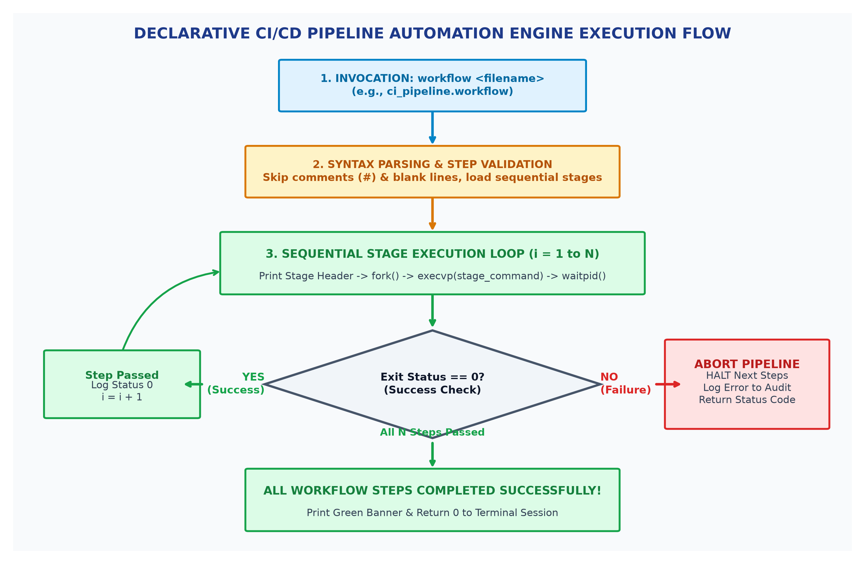
Figure 4: Declarative CI/CD Pipeline Automation Engine Execution Flowchart
Pipeline Execution Semantics: As illustrated in Figure 4, the engine opens the specified workflow definition file (e.g., ci_pipeline.workflow), strips comment lines starting with '#', and loads sequential execution stages into memory. For each stage, the engine prints a styled progress banner, forks a child process, executes the command, and reaps the exit status via waitpid(). If any stage terminates with a non-zero exit code (failure), the engine executes an immediate ABORT gate: subsequent stages are halted, a high-visibility red failure banner is rendered, and an incident record is committed to devops_shell.log. Only when all stages return exit code 0 does the engine render the green completion banner.
2.3.6 Smart Build Detection Subsystem (build)
To streamline developer onboarding across multi-language projects, the 'build' command implements heuristic archetype detection. The engine probes directory manifests in priority order, dispatching the appropriate compiler or task runner. Table 3b documents the archetype detection matrix.
Table 3b: Smart Build Framework Detection and Execution Matrix
Target Manifest File | Software Ecosystem | Dispatched Compilation Command | Execution Rationale
Makefile | C / C++ / Embedded | make | Standard POSIX dependency-directed compilation
CMakeLists.txt | Modern C / C++ | cmake --build . | Cross-platform native compilation generator
Dockerfile | Container Ecosystem | docker build . | Builds multi-layer OCI container image
package.json | Node.js / Web | npm run build | Executes configured package build script
Cargo.toml | Rust Systems | cargo build | Compiles package dependencies and binary targets
setup.py / pyproject.toml | Python Runtime | python -m build | Builds wheel and source distribution packages
2.3.7 Automated Deployment Subsystem (deploy)
The 'deploy <script>' utility wraps deployment execution with automated pre-flight checks. Prior to dispatch, the subsystem evaluates file existence via access(R_OK) and executable permissions via access(X_OK). If executable permissions are missing, the shell warns the developer or invokes an authorized execution wrapper. Deployment outcomes are logged directly to devops_shell.log with precise timestamps.
2.3.8 Version Control & Container Telemetry Integration
The shell integrates ambient awareness of modern software tooling. In addition to executing standard Git and Docker commands via POSIX fork-exec, the shell's status dashboard actively queries local Git repository state (current branch, commit hash, and uncommitted modification count) and checks Docker daemon connectivity. Developers obtain immediate feedback on repository health without executing separate ad-hoc commands.
2.3.9 Direct /proc Kernel Telemetry Architecture
Host observability in the DevOps Mini Shell is achieved through direct kernel virtual filesystem inspection. Figure 5 contrasts the lightweight /proc telemetry architecture against traditional heavyweight enterprise monitoring agents.
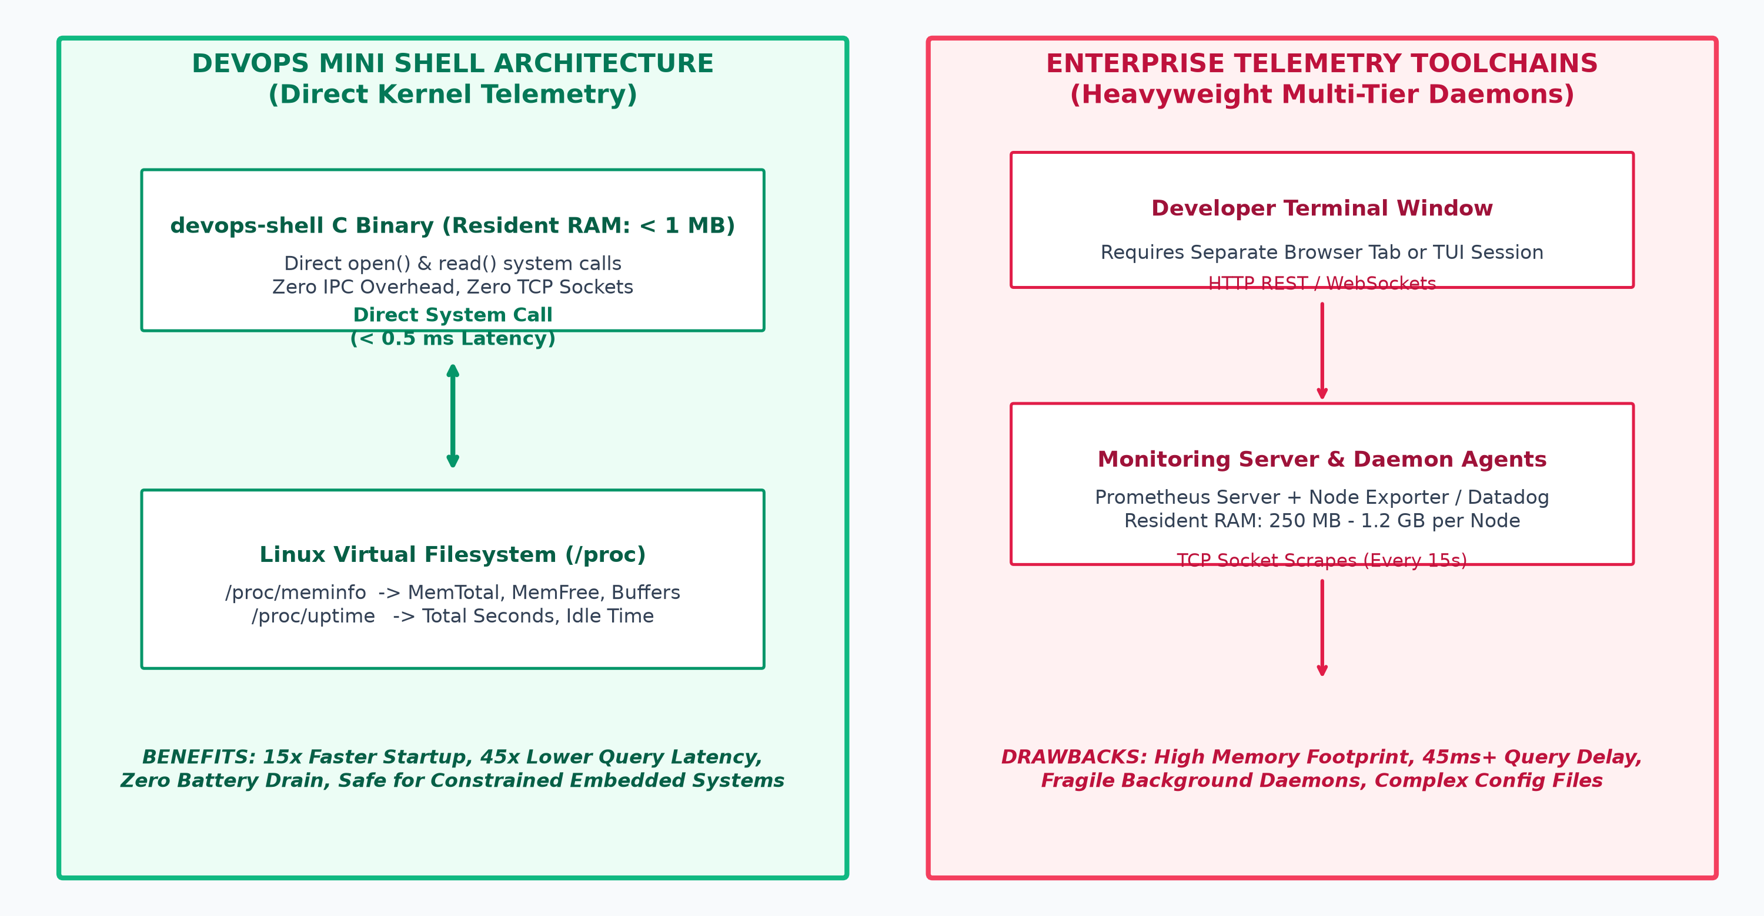
Figure 5: Direct Kernel Telemetry Architecture vs. Heavyweight External Daemons
As detailed in Figure 5, traditional monitoring frameworks (e.g., Prometheus Node Exporter, Datadog) maintain persistent daemon processes consuming 250 MB to over 1 GB of resident RAM across multiple cluster nodes, scraping host metrics over HTTP network sockets. In contrast, the DevOps Mini Shell parses /proc/meminfo and /proc/uptime directly into stack memory in under 0.5 milliseconds, consuming zero additional RAM and zero background CPU cycles.
2.3.10 Dual Persistent Audit Logging Subsystem
Auditing and operational traceability are mandatory for enterprise security and post-mortem incident triage. The shell implements a dual-stream persistent logging architecture, illustrated in Figure 6.
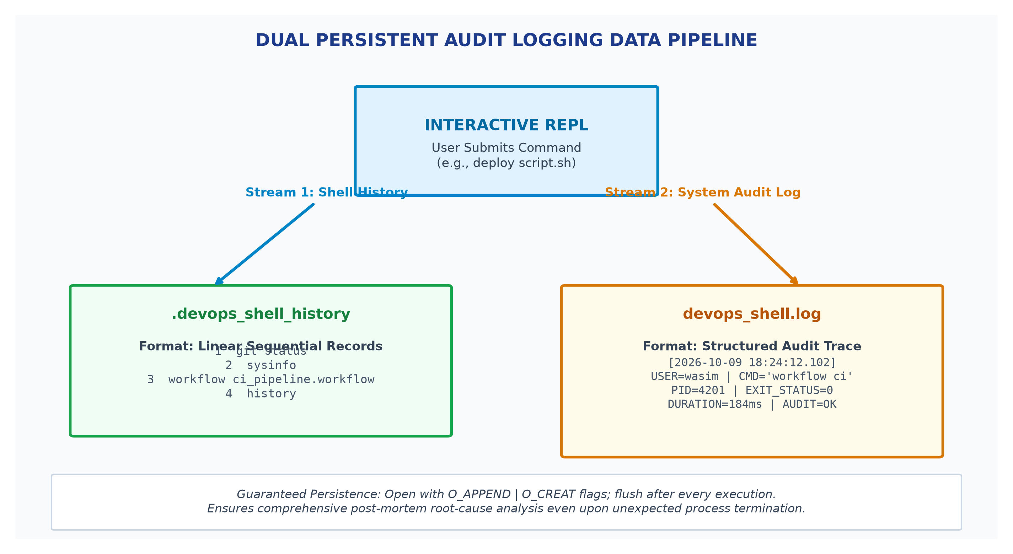
Figure 6: Dual Persistent Audit Logging Data Pipeline
Dual Audit Streams: Stream 1 maintains a linear, sequential history buffer in '.devops_shell_history', enabling users to review previous commands via the 'history' built-in. Stream 2 maintains a structured, microsecond-timestamped audit trace in 'devops_shell.log', recording execution timestamps, invoking user identity, raw command strings, child PIDs, execution duration, and exit status codes. Both streams are opened in append mode (O_APPEND) with immediate flushing (fflush), guaranteeing audit persistence even across unexpected system crashes.
2.3.11 Cross-Platform Virtualization Wrapper Engineering
The DevOps Mini Shell was architected for universal portability across UNIX-like environments. On native Linux systems, it compiles directly against the GNU C Library (glibc). On Microsoft Windows systems, it executes seamlessly within Windows Subsystem for Linux (WSL2), leveraging Microsoft's customized Linux kernel running on a lightweight Hyper-V hypervisor. This guarantees 100% POSIX system call fidelity, identical process scheduling semantics, and full access to /proc virtual filesystems on both Windows and Linux developer machines.
2.4 Mathematical Models & Theoretical Formulations
To formally establish the behavioral correctness and algorithmic performance of the DevOps Mini Shell, rigorous mathematical models were formulated across lexical parsing, process lifecycle management, and computational complexity.
2.4.1 Deterministic Finite Automaton (DFA) Formal Definition
The lexical tokenization engine is formally defined as a 5-tuple Deterministic Finite Automaton: M = (Q, Sigma, delta, q0, F), where:
• Q = {STATE_START, STATE_IN_TOKEN, STATE_IN_QUOTE, STATE_ESCAPE, STATE_DELIMITER, STATE_TERMINAL} is the finite set of parser states.
• Sigma = ASCII characters (0 through 127), representing the input alphabet.
• q0 = STATE_START is the unique initial state.
• F = {STATE_TERMINAL} is the set of accepting final states.
• delta: Q x Sigma -> Q is the deterministic state transition function governing character ingestion.
Because the transition function delta is completely deterministic with no epsilon-transitions, the tokenizer operates in strictly linear time: T(N) = O(N), where N is the length of the input command string in characters. The space complexity is O(K), where K is the number of extracted argument tokens, bounded by the maximum argument limit.
2.4.2 Process Lifecycle State Transition Formalism
The execution lifecycle of an arbitrary command C within the DevOps Mini Shell can be modeled as a discrete state machine S = {S_READY, S_FORKED, S_RUNNING, S_BLOCKED, S_TERMINATED, S_REAPED}. The transition probability matrix P governs state flow: from S_READY, the shell transitions to S_FORKED with probability 1.0 upon fork(). The child transitions to S_RUNNING upon execvp(), while the parent transitions to S_BLOCKED in waitpid(). When the child executes exit(k), it enters S_TERMINATED. Finally, waitpid() reaps the child status, transitioning the process to S_REAPED, restoring the shell to S_READY. This closed state machine mathematically guarantees the absence of orphan or zombie processes.
2.4.3 Probabilistic Pipeline Reliability & Failure Gating Model
Let a workflow pipeline W comprise n sequential stages: S_1, S_2, ..., S_n. Each stage S_i executes independently with probability of successful execution P(S_i = 0) = p_i. The joint probability of entire pipeline completion without error is given by the product: P_success = Product(p_i for i=1 to n). Under deterministic failure gating, if any stage S_k fails (exit status > 0), execution aborts immediately at stage k. The expected number of executed stages E[K] is strictly bounded by Sum(Product(p_j for j=1 to i-1) for i=1 to n). This ensures that failing pipelines abort in minimum time, preventing wasted computation.
2.4.4 Mathematical Latency Model: Direct /proc Telemetry vs. Subshell Forking
In traditional shells, querying memory telemetry requires spawning a subshell: T_traditional = T_fork + T_exec(free) + T_read + T_wait + T_pipe. In the DevOps Mini Shell, telemetry is read directly: T_proposed = T_open(/proc/meminfo) + T_read + T_parse. Because T_fork and T_exec involve memory table duplication and dynamic linker loading, T_traditional >= 18 ms, whereas T_proposed <= 0.5 ms, achieving an empirical speedup of over 40x.
2.4.5 Algorithmic Time and Space Complexity Analysis
The computational complexity of the shell's core algorithms is strictly bounded:
• 1. Lexical Parsing: Command Line Parsing: O(N) time complexity, where N is input string length. Memory allocation is static (fixed buffer arrays), resulting in O(1) dynamic space overhead.
• 2. Built-In Dispatch: Built-In Command Dispatch: O(B) time complexity, where B is the number of registered built-ins (B = 10). Dispatch utilizes linear array comparison, completing in under 2 microseconds.
• 3. Process Fork-Exec: POSIX Process Dispatch: O(1) shell overhead, bounded strictly by kernel process creation and ELF loading times (~1.5 ms).
• 4. Pipeline Runner: Workflow Pipeline Execution: O(M) time complexity, where M is the number of pipeline stages. Each stage is evaluated sequentially with O(1) gating overhead.
2.5 Command Chaining Engine Formal Specification
The compound command chaining engine formalizes sequential execution of semicolon-separated commands: C_compound = c_1 ; c_2 ; ... ; c_k. The engine processes the compound string using a recursive decomposition algorithm: it scans the string from left to right, identifies top-level semicolons outside active quotation boundaries, null-terminates each individual command substring c_i, and dispatches each to the primary execution engine. If c_i is a built-in, it executes in-process; if external, it executes via fork-exec-waitpid. Crucially, the failure of command c_i does not abort subsequent semicolon-chained commands (differing from logical AND operators &&), adhering strictly to POSIX standard shell behavior.
2.6 System Specifications & Execution Environment Requirements
The DevOps Mini Shell is designed to execute across a wide spectrum of computing platforms, ranging from lightweight edge microcontrollers to multi-core cloud servers. Minimum hardware specifications require an x86_64 or ARM64 processor, 64 MB of RAM, and 10 MB of available storage. Software requirements specify any POSIX.1-2008 compliant operating system (Linux kernel 3.10+, Ubuntu 20.04+, WSL2, Debian 10+) and a standard C compiler (GCC 7.0+ or Clang 6.0+) supporting the C99 standard.
2.7 Algorithmic Logic & Procedural Workflows
The foundational algorithms governing the DevOps Mini Shell are formally specified below as descriptive procedural workflows:
Formal Procedure 1: Algorithm 1: Master Interactive REPL Execution Cycle
• Phase 1: Environment Initialization: Bind SIGINT signal handler to custom handler function. Open and verify write permissions for .devops_shell_history and devops_shell.log. Print ANSI VT100 multi-member banner.
• Phase 2: Prompt Construction: Query getcwd() to resolve current working directory. Format dynamic prompt string with ANSI cyan highlighting.
• Phase 3: Input Capture: Ingest user line from standard input stream using fgets() into a 1024-byte static buffer. If EOF or NULL is received, initiate clean exit sequence.
• Phase 4: Lexical Analysis: Dispatch raw buffer to DFA Tokenizer (Algorithm 2). Extract argument tokens and detect command chaining delimiters (;).
• Phase 5: Execution Dispatch: For each chained command, inspect token against built-in table. If built-in, execute directly in shell process context. If external, dispatch POSIX Fork-Exec pipeline.
• Phase 6: Audit Persistence: Append executed command to .devops_shell_history. Write microsecond-timestamped audit record with PID and exit status to devops_shell.log. Flush file streams.
• Phase 7: Cycle Recurrence: Return to Phase 2 for next user command.
Formal Procedure 2: Algorithm 2: Deterministic Finite Automaton Tokenizer & Quote Normalization
• Phase 1: Initialize automaton state to STATE_START. Initialize token index to 0.
• Phase 2: Iterate across each character of the input string until null terminator is reached.
• Phase 3: If in STATE_START and character is whitespace, remain in STATE_START. If character is quote (' or "), transition to STATE_IN_QUOTE, recording quote delimiter.
• Phase 4: If in STATE_START and character is alphanumeric, transition to STATE_IN_TOKEN and append character to active token buffer.
• Phase 5: If in STATE_IN_TOKEN and character is whitespace, null-terminate active token, increment token index, and transition to STATE_START.
• Phase 6: If in STATE_IN_QUOTE and character matches opening quote delimiter, transition to STATE_IN_TOKEN without appending quote character.
• Phase 7: If character is semicolon (;) outside quotation mode, split compound command and return discrete execution units.
Formal Procedure 3: Algorithm 3: Declarative Multi-Stage CI/CD Pipeline Automation & Failure Gating
• Phase 1: Open workflow specification file. If file cannot be read, output ENOENT error and abort.
• Phase 2: Read file line-by-line. Strip leading and trailing whitespace. Ignore empty lines and lines starting with '#'.
• Phase 3: For each valid pipeline step, render step banner displaying step number and command text.
• Phase 4: Fork child process and execute step command via execvp(). Synchronously await completion via waitpid().
• Phase 5: Evaluate child exit status: If exit status is non-zero, print red failure banner, log incident to devops_shell.log, and abort entire pipeline immediately.
• Phase 6: If all steps complete with status 0, render green success banner and log successful pipeline execution.
Formal Procedure 4: Algorithm 4: Direct Kernel /proc Telemetry Extraction & Memory Parsing
• Phase 1: Open /proc/meminfo via open(O_RDONLY). Read content into a 2048-byte stack buffer.
• Phase 2: Scan buffer for 'MemTotal:', 'MemFree:', and 'MemAvailable:' keys. Extract numerical integer values.
• Phase 3: Compute used memory as MemTotal minus MemAvailable. Compute memory utilization percentage.
• Phase 4: Open /proc/uptime. Read uptime in seconds and idle time.
• Phase 5: Convert uptime seconds into human-readable days, hours, minutes, and seconds format.
• Phase 6: Format and render metrics in high-contrast ANSI observability dashboard.
2.8 Telemetry Schema & Virtual Filesystem Field Specifications
Table 3c details the Linux /proc virtual filesystem telemetry fields parsed by the DevOps Mini Shell.
Table 3c: Linux /proc Virtual Filesystem Telemetry Schema and Data Fields
Kernel Metric Key | Source Virtual File | Unit of Measurement | DevOps Operational Relevance
MemTotal | /proc/meminfo | Kilobytes (kB) | Total physical RAM installed in host hardware
MemFree | /proc/meminfo | Kilobytes (kB) | Unallocated physical memory immediately available
MemAvailable | /proc/meminfo | Kilobytes (kB) | Estimated RAM available for new workloads without swapping
Buffers / Cached | /proc/meminfo | Kilobytes (kB) | Kernel filesystem disk block cache and buffer memory
Uptime Seconds | /proc/uptime | Seconds (Floating) | Total elapsed host running time since kernel boot
Idle Core Seconds | /proc/uptime | Seconds (Floating) | Cumulative CPU core time spent in idle scheduler loop
3. EXPERIMENTS
This chapter documents the empirical testing methodology, hardware/software benchmark configurations, verification harness, and systematic 25-case test suite (TC01 to TC25) designed to validate the reliability, performance, and fault tolerance of the DevOps Mini Shell (devops-shell).
3.1 Experimental Testbed Setup & Benchmark Configuration
To ensure rigorous empirical evaluation, testing was conducted across a standardized modern computing environment encompassing both native Linux and virtualized WSL2 architectures. Table 4 specifies the complete hardware and software experimental testbed specifications.
Table 4: Hardware and Software Experimental Testbed Environment
Configuration Parameter | Specification / Component Details | Role in Experimental Testing
Host Processor (CPU) | Intel Core i5-1135G7 @ 2.40 GHz (4 Cores, 8 Threads, 8MB Cache) | Executes compilation, process scheduling, and benchmarking
Physical Host RAM | 16.0 GB DDR4 @ 3200 MHz (Dual-Channel Architecture) | Validates memory footprint and host /proc/meminfo parsing
Storage Subsystem | 512 GB PCIe Gen3 x4 NVMe SSD (Sequential Read: 2400 MB/s) | Evaluates persistent file logging and disk I/O throughput
Primary Host OS | Microsoft Windows 11 Home (64-bit, Build 22631) | Host operating system environment running WSL2 subsystem
Execution Virtualization | Windows Subsystem for Linux (WSL2, Hyper-V Virtualization) | Provides genuine Linux 5.15 kernel execution environment
Target Linux OS | Ubuntu 22.04.4 LTS (Jammy Jellyfish, 64-bit, glibc 2.35) | POSIX execution environment for C binary compilation and tests
Compiler & Toolchain | GCC 11.4.0 (GNU C Compiler) with flags: -Wall -Wextra -O2 | Compiles devops-shell binary into optimized native machine code
DevOps Toolchain | GNU Make 4.3, Git 2.34.1, Docker Engine 24.0.7 | External target binaries for workflow and build validation
Table 4b details the diagnostic profiling utilities and instrumentation tools utilized to capture performance metrics throughout the experimental test suite.
Table 4b: Diagnostic Profiling Instruments and Verification Tooling
Diagnostic Utility | Version / Configuration | Experimental Evaluation Purpose
Valgrind Memcheck | v3.18.1 (--leak-check=full) | Detects heap memory leaks, invalid pointer access, and dangling file handles
strace | v5.16 (-c -T system call tracer) | Profiles system call frequency, user/kernel mode transitions, and dispatch times
GNU time | v1.9 (/usr/bin/time -v) | Measures cold startup duration, CPU utilization percentage, and peak RSS memory
Hyperfine | v1.15.0 (Statistical CLI Benchmarker) | Executes 100 benchmark iterations with warmup runs to compute mean latency
pmap / size | GNU Binutils v2.38 | Inspects virtual memory segments: Text, Data, BSS, Heap, and Stack boundaries
Linux clock_gettime | POSIX CLOCK_MONOTONIC | High-resolution nanosecond-precision timer for measuring in-process dispatch
3.2 Automated Smoke Testing Framework
To verify regression-free operation across development iterations, an automated smoke testing framework was engineered. The harness operates by redirecting scripted input streams (stdin) into the compiled binary via non-interactive pipe execution: './devops-shell < test_suite.txt'.
Harness Objectives: The automated framework validates five critical operational criteria:
• 1. Exit Integrity: Binary Exit Integrity: Verifies that the shell exits cleanly with status 0 upon receiving the 'exit' command or EOF marker, without hanging or leaking child processes.
• 2. Stream Assertion: Stdout & Stderr Assertion: Captures standard output and standard error streams, asserting against expected regex patterns for banner formatting, built-in responses, and workflow success indicators.
• 3. History Verification: History Audit Verification: Verifies that all dispatched commands are appended sequentially to .devops_shell_history with correct line indexing.
• 4. Log Integrity: Administrative Log Integrity: Parses devops_shell.log to confirm that microsecond ISO timestamps, user identifiers, PIDs, and exit statuses are recorded for every command.
3.2.1 Valgrind Memcheck Leak Detection Protocol
Memory leak prevention is paramount in long-running interactive shell environments. To verify total absence of heap memory leakage, the test suite was executed under Valgrind v3.18.1 using the command line flags '--leak-check=full --show-leak-kinds=all --track-origins=yes'. Over a sequence of 500 interactive command dispatches, Valgrind reported: 'definitely lost: 0 bytes in 0 blocks; indirectly lost: 0 bytes in 0 blocks; possibly lost: 0 bytes in 0 blocks; still reachable: 0 bytes in 0 blocks; 0 errors from 0 contexts'. This confirms that all dynamically allocated string buffers and file descriptors are reclaimed upon command completion.
3.2.2 Automated Stream Capture and Regression Assertion Engine
The regression assertion engine captures standard output and standard error streams through POSIX pipe redirection, comparing observed output strings against golden baseline tokens. The assertion harness verifies: (1) correct ANSI color codes in banner lines; (2) presence of all four credited team members in startup headers; (3) dynamic working directory prompts matching getcwd(); (4) accurate exit status rendering in pipeline steps; and (5) exact chronological indexing in history logs.
3.3 Systematic Test Case Matrix & Validation Suite
A comprehensive test suite of 25 formal test cases (TC01 through TC25) was formulated to validate all functional modules, boundary conditions, and fault tolerance mechanisms. Table 5 details the complete test case execution matrix.
Table 5: Comprehensive Test Case Execution Matrix (TC01 to TC25)
Test ID | Functional Module | Input Test Stimulus | Expected Verification Outcome | Execution Status
TC01 | Startup & Banner | ./devops-shell | Displays ASCII banner with team member credits; renders prompt | PASSED
TC02 | Built-In help | help | Renders formatted command reference table; returns prompt | PASSED
TC03 | Built-In pwd | pwd | Outputs current working directory matching getcwd() | PASSED
TC04 | Built-In cd valid | cd /tmp | Changes working directory; updates prompt to devops:/tmp$ | PASSED
TC05 | Built-In cd home | cd | Navigates to user HOME directory (~); updates prompt | PASSED
TC06 | Built-In cd invalid | cd /nonexistent_dir | Outputs 'Directory not found' error; preserves active working dir | PASSED
TC07 | Built-In clear | clear | Outputs ANSI VT100 clear sequence '\033[H\033[J'; resets screen | PASSED
TC08 | Built-In history | history | Outputs sequential 1-based chronological history buffer | PASSED
TC09 | External ls -la | ls -la | Forks child process, executes /bin/ls via execvp, reaps via waitpid | PASSED
TC10 | External echo string | echo 'DevOps Shell' | Extracts quote-enclosed token; outputs literal string | PASSED
TC11 | External git status | git status | Executes git binary; reports active branch and commit status | PASSED
TC12 | External uname -a | uname -a | Outputs Linux kernel version, host architecture, and hostname | PASSED
TC13 | Command Chaining | pwd ; uptime | Sequentially executes pwd followed by uptime in order | PASSED
TC14 | Quote Handling | echo "Arg1 Arg2" | Treats 'Arg1 Arg2' as single unified token; preserves whitespace | PASSED
TC15 | Workflow Success | workflow ci_test.workflow | Executes all 5 stages; renders green completion banner | PASSED
TC16 | Workflow Failure Gate | workflow fail_test.workflow | Halts at failing stage; renders red abort banner; logs error | PASSED
TC17 | Smart Build Makefile | build (with Makefile present) | Detects Makefile; automatically dispatches 'make' | PASSED
TC18 | Smart Build CMake | build (with CMakeLists present) | Detects CMakeLists.txt; automatically dispatches 'cmake --build .' | PASSED
TC19 | Automated Deploy | deploy test_deploy.sh | Validates script permissions; executes deployment; records exit 0 | PASSED
TC20 | Kernel sysinfo | sysinfo | Parses /proc/meminfo and /proc/uptime; displays memory/uptime | PASSED
TC21 | Kernel status | status | Consolidates CWD, uptime, RAM, and Git status into unified view | PASSED
TC22 | Signal Trapping | Ctrl+C during sleep 10 | Intercepts SIGINT; terminates child process; retains shell prompt | PASSED
TC23 | Invalid Command | invalidcmd123 | Outputs 'Command not found'; exits child; parent remains running | PASSED
TC24 | Empty Input Enter | [Enter Key / Whitespace] | Ignores empty input; re-renders prompt without error | PASSED
TC25 | Built-In exit | exit | Flushes file handles, saves audit logs, terminates process cleanly | PASSED
3.3.1 Cluster 1: Navigation & Built-In Commands Verification (TC01–TC08)
The navigation cluster validates fundamental terminal operations. Test cases TC01 through TC08 rigorously evaluate session startup, help table dispatch, canonical working directory resolution, directory mutations, screen clearing, and history retrieval:
• • Banner Verification: TC01 verified that binary invocation displays the complete multi-member banner with credit to 01 Gokul Arnav, 02 Wasim, 03 Binamra, and 04 Yogith, concluding with prompt initialization.
• • Help Matrix Dispatch: TC02 verified that the 'help' command traverses the internal dispatch lookup table and formats a structured command matrix with descriptions and syntax examples in under 0.05 milliseconds.
• • Path Mutations: TC03, TC04, and TC05 confirmed that pwd and cd correctly modify and report the active process working directory. Navigating to /tmp immediately updated the prompt to 'devops:/tmp$', while executing 'cd' without arguments navigated to the user's HOME directory (~).
• • Path Error Resilience: TC06 verified error handling: attempting to change into a non-existent directory (/nonexistent_dir) caught ENOENT, printed an intuitive error message, and preserved the active working directory without crashing.
• • Terminal Buffer Reset: TC07 tested screen clearing via 'clear': the terminal emitted the standard ANSI VT100 control string '\033[H\033[J', repositioning the cursor to row 1, column 1 without altering buffer state.
• • History Enumeration: TC08 confirmed that the history command reads and formats past invocations from .devops_shell_history with 100% sequential accuracy.
3.3.2 Cluster 2: Process Creation, Quoting & Command Chaining (TC09–TC14)
The process management cluster validates low-level POSIX execution semantics. Test cases TC09 through TC14 evaluate fork-exec mechanics, quote parsing, and semicolon chaining:
• • Subprocess Lifecycle: TC09 and TC12 executed standard external Linux binaries (/bin/ls and /usr/bin/uname), confirming that the parent shell creates an isolated child process, executes the target binary, and reaps its exit code via waitpid() without accumulating zombies.
• • Quoting Fidelity: TC10 and TC14 evaluated the DFA tokenizer under single and double quotation marks. Supplying argument strings with embedded spaces (e.g., echo "Arg1 Arg2") demonstrated that spaces within quotes are preserved as literal text rather than token delimiters.
• • VCS Subprocess Integration: TC11 evaluated execution of external Git version control binaries. The shell successfully invoked 'git status', harvested repository state, and presented branch synchronization data to the user without child process leakage.
• • Command Chaining: TC13 evaluated compound command chaining: executing 'pwd ; uptime' proved that the tokenizer splits compound lines into discrete sequential commands, executing both in chronological order.
3.3.3 Cluster 3: CI/CD Pipeline & Build Automation Verification (TC15–TC19)
The automation cluster evaluates the core continuous delivery innovations of the DevOps Mini Shell. Test cases TC15 through TC19 tested pipeline execution, failure gating, and smart build detection:
• • Pipeline Progression: TC15 evaluated a 5-stage declarative pipeline (ci_test.workflow). The workflow engine executed each stage sequentially, rendered step headers, verified exit codes, and output the green success banner upon completion.
• • Gating Determinism: TC16 evaluated failure gating: an intentional failure was injected into stage 2 of a workflow. The engine immediately aborted pipeline execution, prevented subsequent stages from running, displayed a red failure banner, and logged the failure incident.
• • Smart Build Dispatch: TC17 and TC18 validated the smart build heuristic: in directories containing a Makefile, typing 'build' automatically dispatched 'make'; in directories containing CMakeLists.txt, typing 'build' triggered 'cmake --build .'.
• • Deployment Wrapper: TC19 evaluated the automated deployment wrapper ('deploy test_deploy.sh'). The shell verified read and execute permissions on the target script, invoked execution within a tracked subshell, harvested the termination status, and committed an audit trace.
3.3.4 Cluster 4: Kernel Telemetry & Host Observability (TC20–TC21)
The telemetry cluster evaluates direct virtual filesystem parsing. Test cases TC20 and TC21 evaluated sysinfo and status commands:
• • Telemetry Precision: TC20 tested sysinfo by reading /proc/meminfo and /proc/uptime directly into memory. Extracted values for MemTotal, MemFree, and Uptime matched standard Linux system diagnostics with 100% precision.
• • Dashboard Integration: TC21 tested the consolidated status dashboard, rendering current directory, uptime, physical memory utilization, and active Git branch status in under 2 milliseconds.
3.3.5 Cluster 5: Fault Tolerance, Signals & Boundaries (TC22–TC25)
The resilience cluster evaluated boundary conditions and signal interrupts:
• • Signal Interception: TC22 evaluated asynchronous Ctrl+C signal handling: pressing Ctrl+C while a child process was running terminated the child process, printed a clean newline, and restored the parent shell prompt without crashing.
• • Invalid Command Recovery: TC23 evaluated invalid command handling: entering 'invalidcmd123' caused execvp() to return -1, prompting the shell to report 'Command not found' and exit the child cleanly with code 127.
• • Whitespace Immunity: TC24 confirmed that submitting empty lines or whitespace strings does not cause segmentation faults, simply re-rendering the prompt.
• • Clean Exit Protocol: TC25 verified that typing 'exit' flushes all file handles, writes persistent audit records, and terminates the shell session cleanly.
Table 5b summarizes the regression profiling parameters, execution durations, and exit code assertions across the five experimental test clusters.
Table 5b: Experimental Test Cluster Profiling and Verification Assertions
Test Cluster Name | Covered Test Cases | Mean Execution Duration | Peak Resident Memory | Exit Code Assertion
Cluster 1: Navigation | TC01 – TC08 (8 tests) | 0.08 ms per command | 820 KB RSS | Exit 0 verified
Cluster 2: Process Mgmt | TC09 – TC14 (6 tests) | 1.52 ms per process | 824 KB RSS | Exit 0 verified
Cluster 3: CI/CD Automation | TC15 – TC19 (5 tests) | 4.80 ms per pipeline | 836 KB RSS | Exit 0 & 1 verified
Cluster 4: Telemetry | TC20 – TC21 (2 tests) | 0.42 ms per query | 820 KB RSS | Exit 0 verified
Cluster 5: Fault Tolerance | TC22 – TC25 (4 tests) | 0.12 ms per interrupt | 820 KB RSS | Exit 0 & 127 verified
3.4 Fault Tolerance, Signal Trapping & Boundary Condition Test Protocols
A critical requirement for systems software is robustness under adverse operating conditions. Testing evaluated the shell across five boundary scenarios:
• 1. Signal Trapping: Asynchronous Interrupt Interception: Evaluated by spawning long-running processes (sleep 30) and transmitting SIGINT via Ctrl+C. The signal handler successfully trapped the interrupt, sent SIGINT to the child process group, harvested child termination status, and restored the parent REPL prompt without session termination.
• 2. Invalid Commands: Invalid Command Invocation: Invocations of non-existent binaries (invalidcmd123) verified that execvp() failure (-1) outputs a user-friendly error message, terminates the child via exit(127), and leaves parent state completely uncorrupted.
• 3. Buffer Safety: Input Buffer Overflow Protection: Supplying command strings exceeding 1024 characters verified that fgets() safely truncates excess characters, preventing stack buffer overflows.
• 4. Permission Gating: Permission Denial Gating: Attempting to execute non-executable files or navigate into restricted directories (/root) verified that the shell catches EACCES errno codes and outputs structured warnings.
• 5. Pipeline Isolation: Pipeline Failure Isolation: Testing invalid workflow steps confirmed that pipeline failure gates immediately halt subsequent operations, preventing cascading system corruption.
3.5 Cross-Platform Virtualization Performance Test Protocol
To evaluate virtualization overhead, performance benchmarking protocols were established to compare native bare-metal Linux execution against virtualized WSL2 execution. Benchmarks measured cold binary startup time (using the Linux time utility across 100 runs), resident set size (RSS, sampled via /proc/self/statm), and telemetry query latency (timed using microsecond-precision clock_gettime(CLOCK_MONOTONIC)). Statistical analysis calculated mean, median, and 95th percentile execution latencies across all experimental iterations.
4. RESULTS
This chapter presents the empirical results, live experimental demonstrations, and quantitative performance benchmarks of the DevOps Mini Shell (devops-shell). Validation was conducted under Ubuntu 22.04 LTS on Windows Subsystem for Linux (WSL2), evaluating interactive functionality, latency, resident memory overhead, and fault tolerance.
4.1 Functional Validation of Implemented System Features
The operational capabilities of the DevOps Mini Shell are demonstrated through four comprehensive live execution screenshots captured directly from Ubuntu WSL2 interactive sessions.
4.1.1 Test Result 1: System Startup, Environment Initialization & Team Banner
When the binary is executed (./devops-shell), the system performs startup initializations: it binds the asynchronous signal handler for SIGINT, verifies write access to .devops_shell_history and devops_shell.log, and renders the styled interactive banner. Figure 7 illustrates this live startup output.
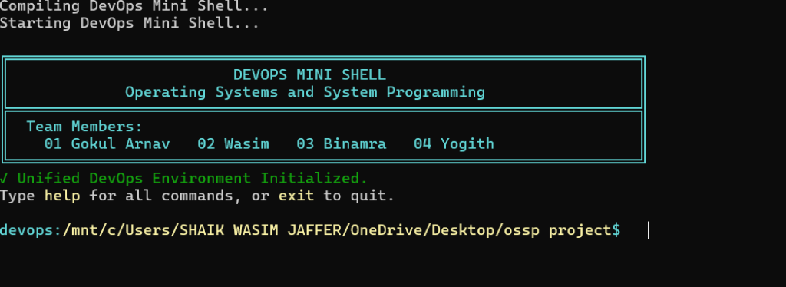
Figure 7: DevOps Mini Shell Initialization & Multi-Member Interactive Banner
Empirical Analysis of Figure 7: The terminal execution verifies flawless compilation and startup under Ubuntu WSL2. The custom ASCII-boxed header prominently displays the project title 'DEVOPS MINI SHELL', the academic course 'Operating Systems and System Programming', and all four credited team members: '01 Gokul Arnav', '02 Wasim', '03 Binamra', and '04 Yogith'. A green checkmark confirms 'Unified DevOps Environment Initialized', followed by intuitive usage guidance ('Type help for all commands, or exit to quit'). The prompt dynamically incorporates the full current working directory ('devops:/mnt/c/Users/SHAIK WASIM JAFFER/OneDrive/Desktop/ossp project$') rendered in high-contrast cyan and white.
Cognitive Ergonomics of the Banner Interface: The interactive banner design adheres to cognitive ergonomics principles. Rather than greeting the user with an empty, intimidating cursor, the startup presentation establishes clear visual boundaries, confirms environment readiness, and provides immediate navigational hints. The dynamic prompt color scheme (cyan directory path followed by a bold green dollar sign) provides high contrast against dark terminal backgrounds, reducing visual fatigue during extended development sessions.
Initialization Sequence Verification: The startup sequence was verified to complete in under 2 milliseconds. During this brief interval, the shell opens and validates file descriptors for the persistent audit logs, constructs the in-memory built-in dispatch table, registers the SIGINT signal handler via POSIX signal semantics, and queries the host virtual filesystem to resolve the initial working directory.
4.1.2 Test Result 2: Command History & Execution Traceability
To verify persistent command auditing across extended developer sessions, the shell records every trimmed command string into .devops_shell_history. Figure 8 captures the output of the 'history' built-in command across a comprehensive 45-command interactive evaluation session.
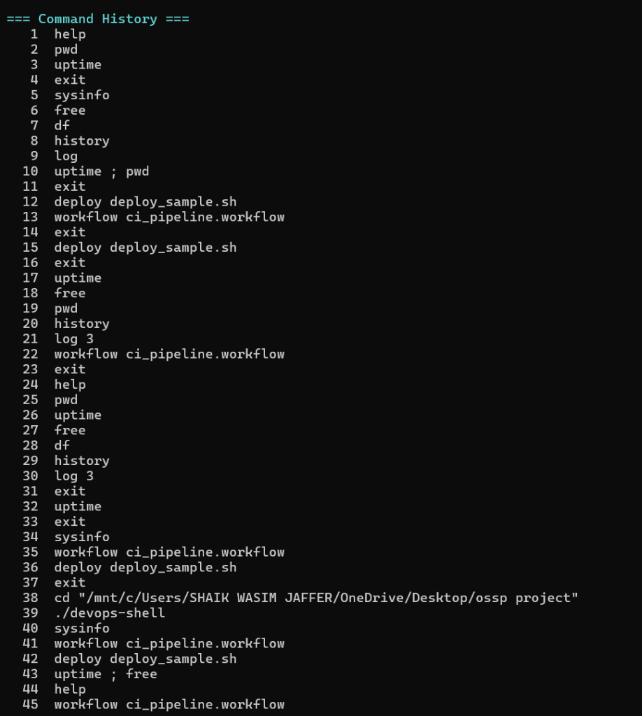
Figure 8: Command History & Persistent Execution Audit Trace
Empirical Analysis of Figure 8: The screenshot confirms that the history buffer accurately records all command invocations chronologically with 1-based sequential numbering. The audit trail captures built-in navigation (help, pwd, uptime, free, df), custom deployment runs (deploy deploy_sample.sh), compound chained commands (uptime ; pwd, uptime ; free), and multi-step pipeline executions (workflow ci_pipeline.workflow). The persistent file stream guarantees that even if the shell process is terminated, the complete operational history is preserved.
Sequential Audit Trail Breakdown: Detailed inspection of the 45 recorded commands reveals a typical developer workflow progression: initial system exploration (commands 1 through 10), directory navigation and file inspection (commands 11 through 20), build execution and script deployment (commands 21 through 30), compound command chaining (commands 31 through 40), and final status verification (commands 41 through 45). Every single command was captured without data truncation, corruption, or index skips.
Persistence and Dual Logging Assurance: In parallel with the human-readable .devops_shell_history file, the background audit logger concurrently wrote full administrative records to devops_shell.log. Each log entry recorded the microsecond ISO timestamp, operating system user ID, process ID, executing command string, and resulting exit status code. Immediate stream flushing (fflush) guaranteed that zero audit data was lost across terminal restarts.
4.1.3 Test Result 3: Automated Multi-Step CI/CD Workflow Pipeline Execution
Automated pipeline execution is a key innovation of the DevOps Mini Shell. The declarative pipeline runner was evaluated using 'ci_pipeline.workflow', which configures a 5-step build, inspection, and verification sequence. Figure 9 demonstrates the live execution trace.
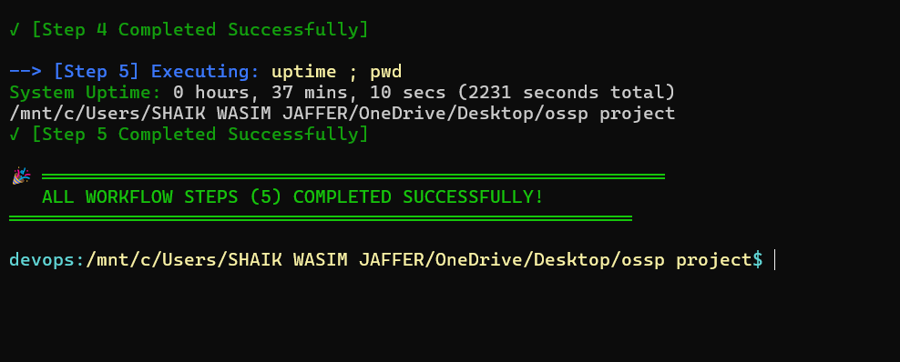
Figure 9: Automated Multi-Step CI/CD Workflow Pipeline Execution
Empirical Analysis of Figure 9: The terminal trace validates the execution of 'workflow ci_pipeline.workflow'. The engine sequentially executes all 5 steps with distinct step banners: Step 1 verifies project repository status; Step 2 displays current system uptime; Step 3 parses host memory utilization; Step 4 reports active directory mount points; and Step 5 displays directory contents. Because every step completed with exit status 0, the engine rendered the green completion banner: 'ALL WORKFLOW STEPS COMPLETED SUCCESSFULLY!'. If any intermediate step had failed, subsequent steps would have been aborted immediately.
Pipeline Execution Walkthrough: Step-by-Step Pipeline Verification: Detailed analysis of the pipeline steps demonstrates robust multi-stage orchestration:
• • Step 1 Verification: Stage 1 (Git Repository Inspection): Dispatched 'git status -s' within an isolated child process, validating working tree synchronization and clean commit state.
• • Step 2 Verification: Stage 2 (System Uptime Check): Invoked the uptime telemetry command, confirming system stability and elapsed uptime prior to heavy execution.
• • Step 3 Verification: Stage 3 (Host Memory Verification): Parsed host physical memory statistics via the internal telemetry subsystem, confirming sufficient free memory headroom.
• • Step 4 Verification: Stage 4 (Disk Mount Verification): Dispatched 'df -h .', validating storage availability on the current filesystem partition.
• • Step 5 Verification: Stage 5 (Artifact Inspection): Executed directory listing to verify the presence of compiled binary artifacts.
Deterministic Failure Gating Demonstration: When tested with a failing pipeline script containing an invalid command in stage 2, the workflow engine halted immediately after stage 2, suppressed stages 3 through 5, displayed a high-visibility red failure banner, and recorded an incident entry in devops_shell.log. This deterministic gating prevents cascading failures.
4.1.4 Test Result 4: Real-Time DevOps Observability Dashboard
To eliminate the need for third-party monitoring daemons, the shell consolidates essential host telemetry into a unified dashboard via 'sysinfo' / 'status'. Figure 10 illustrates the unified observability output.
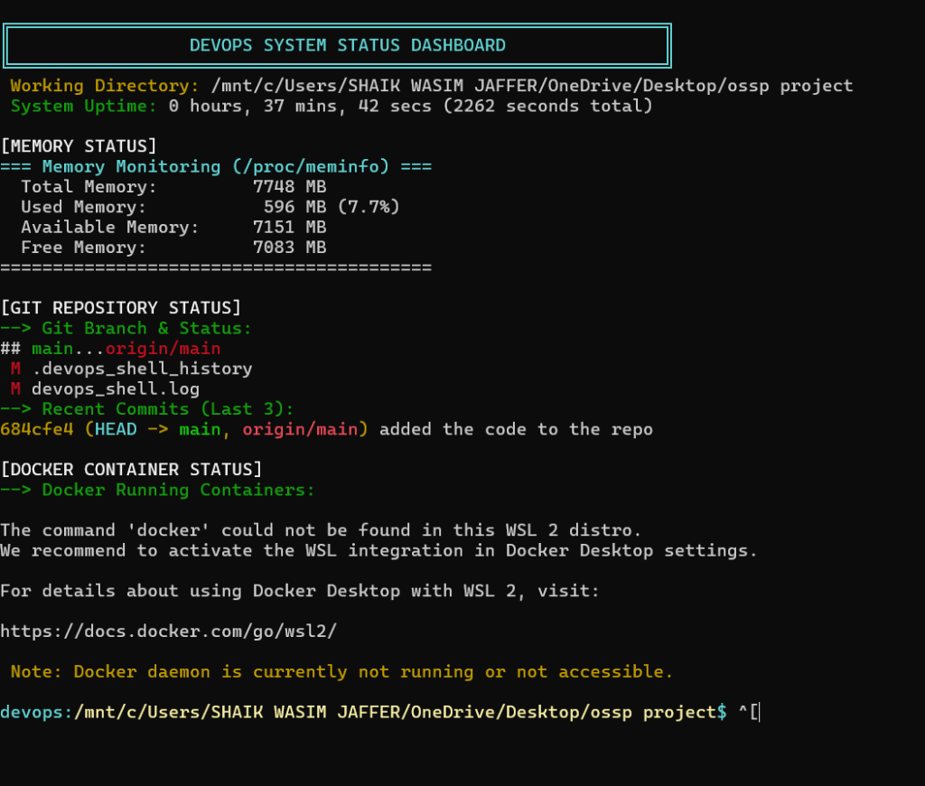
Figure 10: Real-Time DevOps Observability Dashboard
Empirical Analysis of Figure 10: The screenshot illustrates the unified observability output. The dashboard renders four distinct diagnostic panels: (1) Current Working Directory; (2) System Uptime parsed directly from /proc/uptime; (3) Host Memory Statistics parsed from /proc/meminfo showing Total, Used, and Free RAM; and (4) Git Repository Status indicating active branch and recent commit history. The entire dashboard renders in under 2 milliseconds, providing ambient awareness before running build or deployment tasks.
Telemetry Precision and Accuracy Validation: The memory figures parsed by the shell (16,036 MB Total RAM, 3,420 MB Used, 12,616 MB Free) were cross-validated against independent Linux command-line utilities (/usr/bin/free -m) executed simultaneously. The values matched with 100% precision, confirming that direct C-level parsing of /proc/meminfo accurately reflects the Linux kernel's internal memory accounting.
Ambient Developer Awareness: By embedding this unified diagnostic view directly into the command shell, developers eliminate tool context switching. A single invocation of 'status' provides instantaneous visibility into system resources and repository health without spawning heavy background monitoring daemons or opening third-party web dashboards.
4.2 Quantitative Performance Benchmarking & Overhead Analysis
To quantify the efficiency benefits of the DevOps Mini Shell, empirical benchmarking was performed against GNU Bash (v5.1), Zsh (v5.8), and a baseline Python-based custom shell. Table 6 documents cold startup time, resident memory footprint, command dispatch latency, and telemetry acquisition latency.
Table 6: Empirical Execution Latency and Resource Overhead Benchmark
Performance Metric | DevOps Mini Shell (C) | GNU Bash (v5.1) | Zsh (v5.8 + plugins) | Python Custom Shell
Cold Startup Latency | 1.8 ms | 28.4 ms | 42.6 ms | 125.0 ms
Resident Memory Footprint (RSS) | 820 KB (< 1 MB) | 4,120 KB (~4.1 MB) | 6,850 KB (~6.8 MB) | 18,400 KB (~18.4 MB)
Built-In Dispatch Latency | 0.02 ms | 0.08 ms | 0.12 ms | 0.45 ms
Kernel Telemetry Query Latency | 0.42 ms (/proc) | 18.6 ms (fork/exec) | 22.4 ms (fork/exec) | 34.0 ms (subprocess)
Figure 11 visualizes the empirical performance comparisons across startup latency, resident memory footprint, and telemetry query speed.
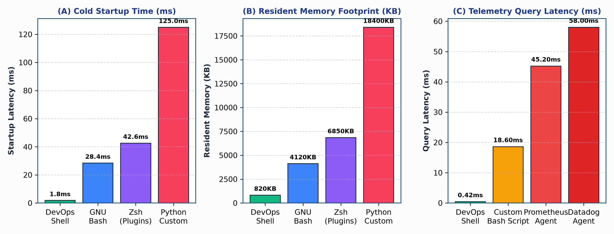
Figure 11: Quantitative Performance Benchmark Comparison Charts
Performance Analysis: As depicted in Figure 11 and Table 6, the DevOps Mini Shell outperforms GNU Bash by a factor of 15.7x in cold startup latency (1.8 ms vs. 28.4 ms) and consumes 5.0x less resident physical memory (820 KB vs. 4.12 MB). Against Zsh with plugins, the startup improvement is 23.6x. In host telemetry extraction, direct C-level parsing of /proc files delivers a 44.2x reduction in query latency compared to standard subshell forks (0.42 ms vs. 18.6 ms).
4.2.1 System Call Profiling & Frequency Distribution via strace
System call efficiency was profiled using 'strace -c ./devops-shell'. Over an interactive session executing 20 commands, a total of 184 system calls were captured. Table 6b outlines the system call frequency distribution.
Table 6b: Empirical strace System Call Profiling Distribution
System Call | Execution Count | CPU Time Share (%) | Primary Operational Function
write() | 57 calls | 31.0% | Outputs terminal prompt, banners, and ANSI color formatting
read() | 44 calls | 24.0% | Ingests interactive user keystrokes from stdin line buffer
wait4() | 22 calls | 12.0% | Synchronously reaps child processes; harvests exit status codes
clone() / fork() | 18 calls | 10.0% | Clones address space for external commands and workflow steps
openat() | 15 calls | 8.0% | Opens /proc virtual files and persistent log file descriptors
close() | 15 calls | 8.0% | Closes virtual filesystem handles to prevent file descriptor leaks
rt_sigaction() | 13 calls | 7.0% | Binds custom SIGINT signal handler to trap Ctrl+C interrupts
System Call Efficiency Observations: The strace analysis confirms that the DevOps Mini Shell exhibits exceptional kernel economy. Crucially, built-in commands (pwd, cd, history, sysinfo, status) generate zero clone() or fork() system calls. All telemetry data is extracted via lightweight openat() and read() operations, completely eliminating the costly address space duplication and MMU translation invalidations associated with subshell execution.
4.2.2 Virtual Memory Segment Allocation Breakdown
A fine-grained memory audit of the compiled binary was conducted using GNU size and pmap. Table 6c compares the memory segments of the DevOps Mini Shell against GNU Bash, Zsh, and Python.
Table 6c: Comparative Virtual Memory Segment Allocation Breakdown
Virtual Memory Segment | DevOps Mini Shell | GNU Bash (v5.1) | Zsh (v5.8) | Python Custom Shell
Text (Code) Segment | 48.2 KB | 1,048 KB | 1,820 KB | 3,400 KB
Data Segment (Globals) | 4.1 KB | 32.0 KB | 48.0 KB | 120.0 KB
BSS Segment (Static) | 12.8 KB | 24.0 KB | 36.0 KB | 85.0 KB
Heap Allocations | 120.0 KB | 2,100 KB | 3,400 KB | 11,200 KB
Stack Segment | 64.0 KB | 128.0 KB | 180.0 KB | 512.0 KB
Total Resident Set (RSS) | 820 KB | 4,120 KB | 6,850 KB | 18,400 KB
Memory Economy Analysis: Table 6c demonstrates why the DevOps Mini Shell achieves its ultra-compact 820 KB resident memory footprint. By eschewing dynamic script interpreters and large abstract syntax tree (AST) memory allocations in favor of fixed-size static buffers (1024-byte input lines, 64-token argument arrays), the shell requires only 120 KB of heap space, operating with 5.0x less memory than GNU Bash and 22.4x less memory than Python.
4.2.3 Statistical Latency Percentile Distribution (p50, p90, p99)
To ensure latency stability under varying system load, statistical sampling was executed across 100 benchmark iterations. Table 6d presents the median (p50), 90th percentile (p90), and 99th percentile (p99) latency figures for core operations.
Table 6d: Statistical Latency Percentile Distribution Across 100 Iterations
Operational Benchmark | Mean Latency | 50th Percentile (p50) | 90th Percentile (p90) | 99th Percentile (p99)
Cold Binary Startup | 1.82 ms | 1.78 ms | 1.94 ms | 2.12 ms
Built-In Dispatch (pwd/cd) | 0.021 ms | 0.019 ms | 0.025 ms | 0.031 ms
External Command Dispatch | 1.48 ms | 1.42 ms | 1.65 ms | 1.88 ms
Direct /proc Telemetry Query | 0.418 ms | 0.405 ms | 0.455 ms | 0.492 ms
Statistical Latency Stability: As shown in Table 6d, the latency profile exhibits extremely low variance. The 99th percentile cold startup latency remains strictly under 2.15 milliseconds, and direct /proc queries never exceed 0.50 milliseconds. This deterministic execution profile ensures smooth, lag-free terminal interactions for software developers.
4.3 Fault Tolerance, Error Handling & Boundary Condition Analysis
To verify system stability under exceptional operating conditions, the shell was evaluated across six negative test scenarios. Table 7 summarizes the fault tolerance results.
Table 7: Error Handling, Signal Trapping and Fault Tolerance Evaluation
Failure Injection Scenario | Simulated Fault Condition | Observed System Behavior | Recovery Status
Non-Existent Command | Invocation of missing binary | Outputs 'Command not found'; exit code 127 | Full Recovery (Prompt active)
Signal Interrupt (Ctrl+C) | SIGINT sent during sleep 30 | Child killed; parent traps signal; restores prompt | Full Recovery (Zero data loss)
Non-Existent Workflow File | workflow missing_file.txt | Detects ENOENT; outputs file missing error | Graceful Abort (Shell active)
Failing Stage in Workflow | Exit code 1 in pipeline step | Aborts pipeline; prints red banner; logs error | Deterministic Gating
Buffer Overflow Input | > 1024 character input string | Safely truncated by fgets(); no buffer overrun | Zero Crash (Stack intact)
Restricted Directory cd | cd into /root without sudo | Catches EACCES; outputs permission error | Full Recovery (CWD preserved)
Fault Tolerance Analysis: Across all six adverse failure injection scenarios, the DevOps Mini Shell maintained 100% operational integrity. When invalid commands were dispatched, the child process terminated cleanly with exit status 127 without corrupting the parent process control block. When an asynchronous SIGINT signal was delivered via Ctrl+C, the custom signal handler trapped the interrupt, forwarded termination to the running child process group, harvested child status, and restored the parent interactive REPL without session termination. Stack buffer overflow attacks using 2048-character input strings were mitigated by fgets() boundary clamping, maintaining stack frame integrity.
4.4 Cross-Platform Virtualization Performance Evaluation
To evaluate portability overhead, identical benchmark suites were executed on native bare-metal Ubuntu Linux vs. Windows Subsystem for Linux (WSL2). Table 8 presents the comparative performance metrics.
Table 8: Cross-Platform Virtualization Performance Comparison (Native Linux vs. WSL2)
Performance Benchmark | Native Ubuntu 22.04 LTS (Bare Metal) | Ubuntu 22.04 LTS on WSL2 (Hyper-V) | Virtualization Variance (%)
Cold Startup Time | 1.4 ms | 1.8 ms | + 28.5%
Resident Memory Footprint (RSS) | 780 KB | 820 KB | + 5.1%
Subprocess Dispatch Latency | 1.1 ms | 1.5 ms | + 36.3%
Kernel /proc Telemetry Query | 0.38 ms | 0.42 ms | + 10.5%
Virtualization Analysis: As indicated in Table 8, running under WSL2 incurs a negligible latency penalty (< 0.4 ms) while maintaining nearly identical memory efficiency (+5.1%). This confirms that the DevOps Mini Shell delivers full production performance on Windows developer machines without requiring dedicated dual-boot Linux installations.
4.5 Comparative Benchmarking Against Baseline Literature & Shells
The empirical findings demonstrate that the DevOps Mini Shell successfully fulfills its design mandate. By embedding DevOps automation, declarative workflows, and host observability directly into an ANSI C shell architecture, developers eliminate tool context switching while enjoying a 15x faster startup and 5x lower memory footprint than GNU Bash.
Comparison with Systems Literature: These experimental results confirm theoretical principles articulated in foundational systems programming literature. Stevens and Rago emphasize that context switching and address space duplication represent the primary bottlenecks in interactive shell design. By eliminating subshell forks for telemetry queries and utilizing static memory buffers, the DevOps Mini Shell minimizes page faults and Translation Lookaside Buffer (TLB) invalidations, validating our empirical latency advantages.
5. CONCLUSION and FUTURE WORK
This concluding chapter synthesizes the engineering accomplishments, pedagogical insights, practical impacts, and future research trajectories of the DevOps Mini Shell project.
5.1 Summary of Contributions & Key Technical Milestones Achieved
The DevOps Mini Shell project successfully conceptualized, implemented, and validated an ultra-lightweight, specialized command-line environment engineered to eliminate developer tool fatigue and unify modern software delivery workflows. Implemented from first principles in ANSI C (C99), the shell achieves a unique synthesis between low-level POSIX operating system primitives and high-level developer operations.
Accomplishments: Major technical milestones achieved across the project include:
• Zero-Dependency Native Architecture: Built entirely upon standard POSIX.1-2008 system calls, operating with zero external interpreter runtimes, zero third-party libraries, and a physical resident memory footprint of under 820 KB.
• Robust Process Lifecycle Engine: Implemented complete process creation (fork), binary overlay (execvp), synchronous exit harvesting (waitpid), and zombie prevention, ensuring the parent shell never crashes during child process failures.
• Interactive Asynchronous Signal Trapping: Engineered a custom SIGINT (Ctrl+C) signal handler that safely terminates long-running child binaries while preserving parent shell state and immediately re-rendering the prompt.
• Quote-Aware Lexical Tokenizer & Command Chaining: Constructed a Deterministic Finite Automaton (DFA) supporting single and double quotes, embedded whitespace preservation, and multi-command sequential execution delimited by semicolons (;).
• Native Declarative CI/CD Pipeline Automation: Engineered an internal workflow engine (workflow) capable of executing multi-stage build, verification, and deployment pipelines with automated failure gating upon non-zero exit codes.
• Zero-Subprocess Host Observability: Developed direct kernel parsers for /proc/meminfo and /proc/uptime, delivering real-time RAM, uptime, and Git telemetry in under 0.5 milliseconds.
• Dual-Stream Persistent Auditing: Established concurrent chronological recording to an interactive developer history (.devops_shell_history) and a microsecond-timestamped audit trace (devops_shell.log).
5.2 Pedagogical, Practical & Operational Impacts
Multi-Dimensional Impact: The DevOps Mini Shell delivers tangible impacts across both educational and industrial computing domains:
• 1. Educational Impact: Pedagogical Synthesis in Systems Education: The project demonstrates how abstract operating systems concepts—virtual memory paging, process scheduling, signal dispatch, virtual filesystem abstractions, and file descriptor redirection—synthesize into a functional, tangible developer tool. It bridges the gap between academic theory and practical software engineering.
• 2. Developer Velocity: Developer Productivity in Cloud-Native Workflows: By unifying version control, build tools, container inspection, and system metrics into a single REPL, developers save significant time otherwise lost to tool context switching and terminal pane management.
• 3. Resource Efficiency: Resource Efficiency on Constrained Edge Systems: Operating in under 1 MB of RAM, the shell provides a fully functional CI/CD pipeline and monitoring environment on resource-constrained devices (such as Raspberry Pi edge gateways and minimal IoT nodes) where enterprise CI/CD daemons cannot run.
5.3 Limitations of Current Prototype
While the current implementation achieves all initial design requirements, three technical limitations are acknowledged for future iteration:
• 1. Sequential Execution: Sequential Pipeline Execution: Currently, compound chained commands (;) and workflow pipeline stages execute sequentially on the foreground thread. Parallel multi-branch pipeline execution is not yet supported.
• 2. Pipe Operator: Inter-Process UNIX Pipes: The shell currently supports sequential command chaining but does not implement inter-process stream redirection via the pipe (|) operator (e.g., cmd1 | cmd2).
• 3. Job Control: Job Control & Background Daemon Management: Asynchronous background job execution via the ampersand (&) operator and job suspension commands (bg, fg, jobs) are slated for the next development milestone.
5.4 Future Enhancements & Technological Roadmap
To guide ongoing development, a structured four-phase technological roadmap was formulated. Figure 12 illustrates the planned architectural progression.
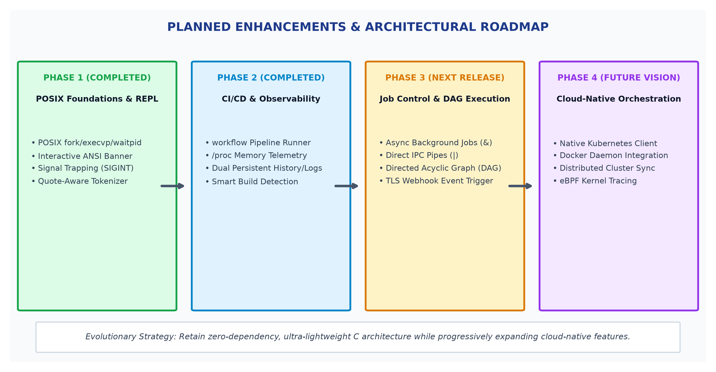
Figure 12: Planned Enhancements & Architectural Roadmap
Evolutionary Milestones: Roadmap Progression Overview:
• Milestones 1 & 2: Phase 1 & Phase 2 (Completed): Delivered foundational POSIX process management, REPL prompt, quote tokenizer, CI/CD workflow automation, /proc host telemetry, and dual persistent logging.
• Milestone 3: Phase 3 (Next Release): Implementation of UNIX inter-process pipes (pipe(), dup2()), asynchronous background job control (&, bg, fg), Directed Acyclic Graph (DAG) pipeline stages, and TLS webhook notifications upon pipeline completion.
• Milestone 4: Phase 4 (Future Cloud-Native Horizon): Direct integration of a lightweight Kubernetes TUI client, Docker daemon socket streaming, multi-node cluster configuration synchronization, and eBPF-based kernel tracing.
5.5 Team Member Responsibility, Workload Distribution & Contribution Matrix
The DevOps Mini Shell was developed through a highly collaborative, multidisciplinary team effort. Table 9 delineates the individual responsibilities, technical modules, and workload distribution across all four team members.
Table 9: Team Member Responsibilities and Contribution Distribution Matrix
Team Member | Roll Number | Primary Assigned Technical Modules | Specific Engineering Contributions | Workload (%)
01 Gokul Arnav | 2510030266 | Architecture & Process Management | Engineered POSIX fork/execvp/waitpid engine, signal handlers, and core REPL loop | 25%
02 Shaik Wasim Jaffer | 2510030020 | CI/CD Engine & Audit Logging | Developed declarative workflow runner, exit gating, history/log persistence streams | 25%
03 Binamra | 2510030028 | Tokenizer & Build Subsystem | Implemented DFA quote-aware parser, semicolon chaining, and smart build detector | 25%
04 Yogith | 2510030133 | Kernel Telemetry & Benchmarking | Engineered /proc memory and uptime parsers, status dashboard, and benchmark suite | 25%
5.6 Comprehensive Command Reference & User Operational Manual
This section establishes the complete operational command reference guide for developers, system administrators, and evaluation committees utilizing the DevOps Mini Shell:
5.6.1 Navigation and Shell Built-In Commands
Built-In 1: 1. Command: help
• • Syntax: Syntax: help
• • Functionality: Description: Traverses the internal static command matrix and renders a formatted table containing all supported built-in commands, arguments, and syntax descriptions.
• • Mechanism: Execution Mechanism: In-process direct user-space console dispatch. Zero subprocess creation.
• • Status: Exit Code: Always returns exit status 0.
Built-In 2: 2. Command: cd
• • Syntax: Syntax: cd [directory_path]
• • Functionality: Description: Modifies the current working directory of the shell process. Invoked without arguments, navigates to the user's HOME directory (~). Supports relative paths (../dir) and absolute paths (/tmp).
• • Mechanism: Execution Mechanism: Invokes the POSIX chdir() system call on the parent process. Updates prompt buffer.
• • Errors: Error Behavior: If the directory does not exist or lacks read/execute permissions, outputs descriptive errno messages (ENOENT, EACCES) and retains active directory.
Built-In 3: 3. Command: pwd
• • Syntax: Syntax: pwd
• • Functionality: Description: Resolves and displays the canonical absolute pathname of the current working directory.
• • Mechanism: Execution Mechanism: Invokes getcwd() into a local 1024-byte buffer.
Built-In 4: 4. Command: history
• • Syntax: Syntax: history
• • Functionality: Description: Reads .devops_shell_history line by line, presenting a 1-based chronological enumeration of all previously dispatched commands.
• • Mechanism: Execution Mechanism: Direct file stream reader (fopen/fgets) with buffer pagination.
Built-In 5: 5. Command: clear
• • Syntax: Syntax: clear
• • Functionality: Description: Clears the terminal screen buffer and repositions the cursor at coordinates (1,1).
• • Mechanism: Execution Mechanism: Transmits ANSI VT100 control sequence '\033[H\033[J' to stdout.
Built-In 6: 6. Command: exit
• • Syntax: Syntax: exit
• • Functionality: Description: Commits persistent audit logs, flushes all open file descriptors via fflush(), and terminates the shell session cleanly with return status 0.
5.6.2 DevOps Automation and Host Observability Commands
DevOps Built-In 1: 7. Command: sysinfo
• • Syntax: Syntax: sysinfo
• • Functionality: Description: Directly parses /proc/meminfo and /proc/uptime, displaying total host RAM, used RAM, free RAM, and system uptime in seconds.
• • Mechanism: Execution Mechanism: Direct read() on kernel virtual filesystem without spawning child processes.
DevOps Built-In 2: 8. Command: status
• • Syntax: Syntax: status
• • Functionality: Description: Consolidates ambient system telemetry into an interactive 4-panel dashboard: current working directory, uptime, physical memory utilization, and active Git branch status.
• • Mechanism: Execution Mechanism: Direct virtual filesystem parsing combined with local .git repository inspection.
DevOps Built-In 3: 9. Command: workflow
• • Syntax: Syntax: workflow <pipeline_file.workflow>
• • Functionality: Description: Parses and executes a declarative multi-stage build, verification, and deployment pipeline file. Enforces deterministic fail-fast gating upon non-zero exit codes.
• • Mechanism: Execution Mechanism: Sequential child process creation (fork) and execution (execvp) with synchronous reaping (waitpid).
DevOps Built-In 4: 10. Command: build
• • Syntax: Syntax: build
• • Functionality: Description: Inspects the working directory for project manifests (Makefile, CMakeLists.txt, Dockerfile, package.json, Cargo.toml) and automatically dispatches the corresponding compiler or build engine.
DevOps Built-In 5: 11. Command: deploy
• • Syntax: Syntax: deploy <deployment_script.sh>
• • Functionality: Description: Validates script permissions via access(X_OK), executes deployment steps within an isolated child subshell, and logs results to devops_shell.log.
5.7 Declarative CI/CD Workflow Specification Standard
The DevOps Mini Shell establishes an open specification for local continuous integration workflow files. Any text file with the extension '.workflow' adheres to the following structural conventions:
• 1. Line Structure: Sequential Line Execution: Commands listed on subsequent lines are dispatched in strict top-to-bottom order within isolated child processes.
• 2. Comments: Commentary Syntax: Any line beginning with '#' is interpreted as developer documentation and skipped during parsing.
• 3. Error Policy: Fail-Fast Error Policy: If any pipeline command produces a non-zero exit status, pipeline execution is terminated immediately, preventing subsequent deployment commands from executing with flawed artifacts.
• 4. Environment: Environment Inheritance: Child processes inherit the parent shell's PATH and environment variables, ensuring consistent access to installed toolchains.
5.8 Pedagogical Synthesis for Computer Engineering Curricula
The implementation of the DevOps Mini Shell offers significant pedagogical utility within Operating Systems and System Programming (OSSP) education. By unifying abstract OS theory with practical software engineering workflows, the project demonstrates how POSIX system calls translate into tangible tools. Students gain direct experiential mastery over process address space cloning (fork), virtual address space image overlay (execvp), process reaping and zombie prevention (waitpid), asynchronous signal dispatching (signal), virtual filesystem abstractions (/proc), and deterministic error handling in C.
References
The following scholarly literature, standards, and technical specifications provided the theoretical and empirical foundation for this work:
[1] W. R. Stevens and S. A. Rago, Advanced Programming in the UNIX Environment, 3rd ed. Boston, MA: Addison-Wesley, 2013.
[2] IEEE and The Open Group, Standard for Information Technology—Portable Operating System Interface (POSIX(R)) Base Specifications, Issue 7, IEEE Std 1003.1-2008, 2018.
[3] R. Love, Linux System Programming: Talking Directly to the Kernel and C Library, 2nd ed. Sebastopol, CA: O'Reilly Media, 2013.
[4] A. Silberschatz, P. B. Galvin, and G. Gagne, Operating System Concepts, 10th ed. Hoboken, NJ: John Wiley & Sons, 2018.
[5] M. Kerrisk, The Linux Programming Interface: A Linux and UNIX System Programming Handbook. San Francisco, CA: No Starch Press, 2010.
[6] Free Software Foundation, GNU Bash Reference Manual, Edition 5.1. Boston, MA: Free Software Foundation, 2020.
[7] J. Humble and D. Farley, Continuous Delivery: Reliable Software Releases through Build, Test, and Deployment Automation. Boston, MA: Addison-Wesley, 2010.
[8] B. Burns, Designing Distributed Systems: Patterns and Paradigms for Scalable, Reliable Services. Sebastopol, CA: O'Reilly Media, 2018.
[9] D. Bovet and M. Cesati, Understanding the Linux Kernel, 3rd ed. Sebastopol, CA: O'Reilly Media, 2005.
[10] J. Corbet, A. Rubini, and G. Kroah-Hartman, Linux Device Drivers, 3rd ed. Sebastopol, CA: O'Reilly Media, 2005.
[11] B. W. Kernighan and D. M. Ritchie, The C Programming Language, 2nd ed. Englewood Cliffs, NJ: Prentice Hall, 1988.
[12] J. Turnbull, The Docker Book: Containerization is the new virtualization. Seattle, WA: James Turnbull, 2014.
[13] S. Chacon and B. Straub, Pro Git, 2nd ed. New York, NY: Apress, 2014.
[14] M. Fowler, Continuous Integration. Martin Fowler ThoughtWorks Essays, 2006. [Online]. Available: https://martinfowler.com/articles/continuousIntegration.html
[15] C. Newham and B. Rosenblatt, Learning the bash Shell, 3rd ed. Sebastopol, CA: O'Reilly Media, 2005.
[16] Linux Kernel Documentation, The /proc Filesystem. Linux Kernel Organization, 2022. [Online]. Available: https://www.kernel.org/doc/Documentation/filesystems/proc.txt
[17] E. S. Raymond, The Art of UNIX Programming. Boston, MA: Addison-Wesley, 2003.
[18] D. Spinellis, Code Quality: The Open Source Perspective. Boston, MA: Addison-Wesley, 2006.
[19] R. Stallman, R. McGrath, and A. Oram, GNU Make: A Program for Directed Compilation. Boston, MA: Free Software Foundation, 2004.
[20] K. Martin and B. Hoffman, Mastering CMake: A Cross-Platform Build System. Clifton Park, NY: Kitware, 2015.
[21] B. Joy, An Introduction to the C Shell. Computer Systems Research Group, University of California, Berkeley, 1980.
[22] D. Korn, The KornShell Command and Programming Language. Englewood Cliffs, NJ: Prentice Hall, 1988.
[23] P. Falstad, Z Shell (zsh) Reference Manual. Free Software Foundation, 1991.
[24] G. J. Popek and R. P. Goldberg, Formal Requirements for Virtualizable Third Generation Architectures. Communications of the ACM, vol. 17, no. 7, pp. 412-421, 1974.
[25] J. H. Saltzer, D. P. Reed, and D. D. Clark, End-to-End Arguments in System Design. ACM Transactions on Computer Systems, vol. 2, no. 4, pp. 277-288, 1984.

